TRƯỜNG ĐẠI HỌC TÀI NGUYÊN VÀ MÔI TRƯỜNG TP.HCM
KHOA: CÔNG NGHỆ THÔNG TIN


NGUYỄN QUANG MẪN_1150080065_11_THMT

TỔNG HỢP LAB LẬP TRÌNH DI ĐỘNG
2025-2026

Mục lục
A.Lab1 1
1. Tạo Trang chủ để liên kết 3 bài 1
Bài 1:Máy tính cầm tay 5
Bài 2:Xúc xắc 11
Bài 3:Gọi điện 15
B.Lab2 21
1.Tạo trang chủ để liên kết các trang 21
Bài 1: Hiện icon và màu nền khác nhau khi nhấp vào 24
Bài 2: Trang loading 26
Bài 3: Trang cá nhân và gọi điện 28
C.Lab3 33
Bài 1:Chương trình đổi tiền tệ 33
Bài 2: Đổi đơn vị chiều dài 49
Bài 3: Custom Button 50
Bài 4: Chương trình cho phép chọn màu 51
Bài 5: Chương trình hiển thị và quản lý các món ăn 52
Bài 6: Sử dụng Custom GridView để thiết kế chương trình 52
D.Lab4: Đề tài truyện ngắn đủ thể loại 52
E.Lab5: Trang đăng nhập và đăng ký 68

A.Lab1

1. Tạo Trang chủ để liên kết 3 bài
AndroidManifest.xml
package com.example.lab1;
import androidx.appcompat.app.AppCompatActivity;
import android.content.Intent;
import android.os.Bundle;
import android.view.View;
import android.widget.Button;
public class Trangchu extends AppCompatActivity {
@Override
protected void onCreate(Bundle savedInstanceState) {
super.onCreate(savedInstanceState);
setContentView(R.layout.trangchu);
Button btnBai1 = findViewById(R.id.btnBai1Calculator);
Button btnBai2 = findViewById(R.id.btnBai2DiceRoller);
Button btnBai3 = findViewById(R.id.btnBai3CallSms);
// Chuyển sang Bài 1: Máy tính
btnBai1.setOnClickListener(new View.OnClickListener() {
@Override
public void onClick(View v) {
Intent intent = new Intent(Trangchu.this, MainActivity.class);
startActivity(intent);
}
});
// Chuyển sang Bài 2: Tung Xúc Xắc
btnBai2.setOnClickListener(new View.OnClickListener() {
@Override
public void onClick(View v) {
Intent intent = new Intent(Trangchu.this, Xucxac.class);
startActivity(intent);
}
});
btnBai3.setOnClickListener(new View.OnClickListener() {
@Override
public void onClick(View v) {
Intent intent = new Intent(Trangchu.this, Goidien.class);
startActivity(intent);
}
});
}
}
Trangchu.java
package com.example.lab1;
import androidx.appcompat.app.AppCompatActivity;
import android.content.Intent;
import android.os.Bundle;
import android.view.View;
import android.widget.Button;
public class Trangchu extends AppCompatActivity {
@Override
protected void onCreate(Bundle savedInstanceState) {
super.onCreate(savedInstanceState);
setContentView(R.layout.trangchu);
Button btnBai1 = findViewById(R.id.btnBai1Calculator);
Button btnBai2 = findViewById(R.id.btnBai2DiceRoller);
Button btnBai3 = findViewById(R.id.btnBai3CallSms);
// Chuyển sang Bài 1: Máy tính
btnBai1.setOnClickListener(new View.OnClickListener() {
@Override
public void onClick(View v) {
Intent intent = new Intent(Trangchu.this, MainActivity.class);
startActivity(intent);
}
});
// Chuyển sang Bài 2: Tung Xúc Xắc
btnBai2.setOnClickListener(new View.OnClickListener() {
@Override
public void onClick(View v) {
Intent intent = new Intent(Trangchu.this, Xucxac.class);
startActivity(intent);
}
});
btnBai3.setOnClickListener(new View.OnClickListener() {
@Override
public void onClick(View v) {
Intent intent = new Intent(Trangchu.this, Goidien.class);
startActivity(intent);
}
});
}
}
TrangChu.xml
<?xml version="1.0" encoding="utf-8"?>
<LinearLayout
xmlns:android="http://schemas.android.com/apk/res/android"
xmlns:tools="http://schemas.android.com/tools"
android:layout_width="match_parent"
android:layout_height="match_parent"
android:orientation="vertical"
android:gravity="center"
android:padding="32dp"
tools:context=".Trangchu">
<TextView
android:layout_width="wrap_content"
android:layout_height="wrap_content"
android:text="Chọn Bài Tập"
android:textSize="30sp"
android:textStyle="bold"
android:layout_marginBottom="50dp"/>
<Button
android:id="@+id/btnBai1Calculator"
android:layout_width="match_parent"
android:layout_height="wrap_content"
android:text="Bài 1: Máy Tính Đơn Giản"
android:textSize="20sp"
android:padding="16dp"
android:layout_marginBottom="20dp"/>
<Button
android:id="@+id/btnBai2DiceRoller"
android:layout_width="match_parent"
android:layout_height="wrap_content"
android:text="Bài 2: Tung Xúc Xắc"
android:textSize="20sp"
android:padding="16dp"/>
<Button
android:id="@+id/btnBai3CallSms"
android:layout_width="match_parent"
android:layout_height="wrap_content"
android:text="Bài 3: Gọi và Nhắn Tin"
android:textSize="18sp"
android:padding="16dp"/>
<TextView
android:layout_width="wrap_content"
android:layout_height="wrap_content"
android:text="Nguyễn Quang Mẫn"
android:textSize="30sp"
android:textStyle="bold"
android:layout_marginBottom="50dp"/>
</LinearLayout>
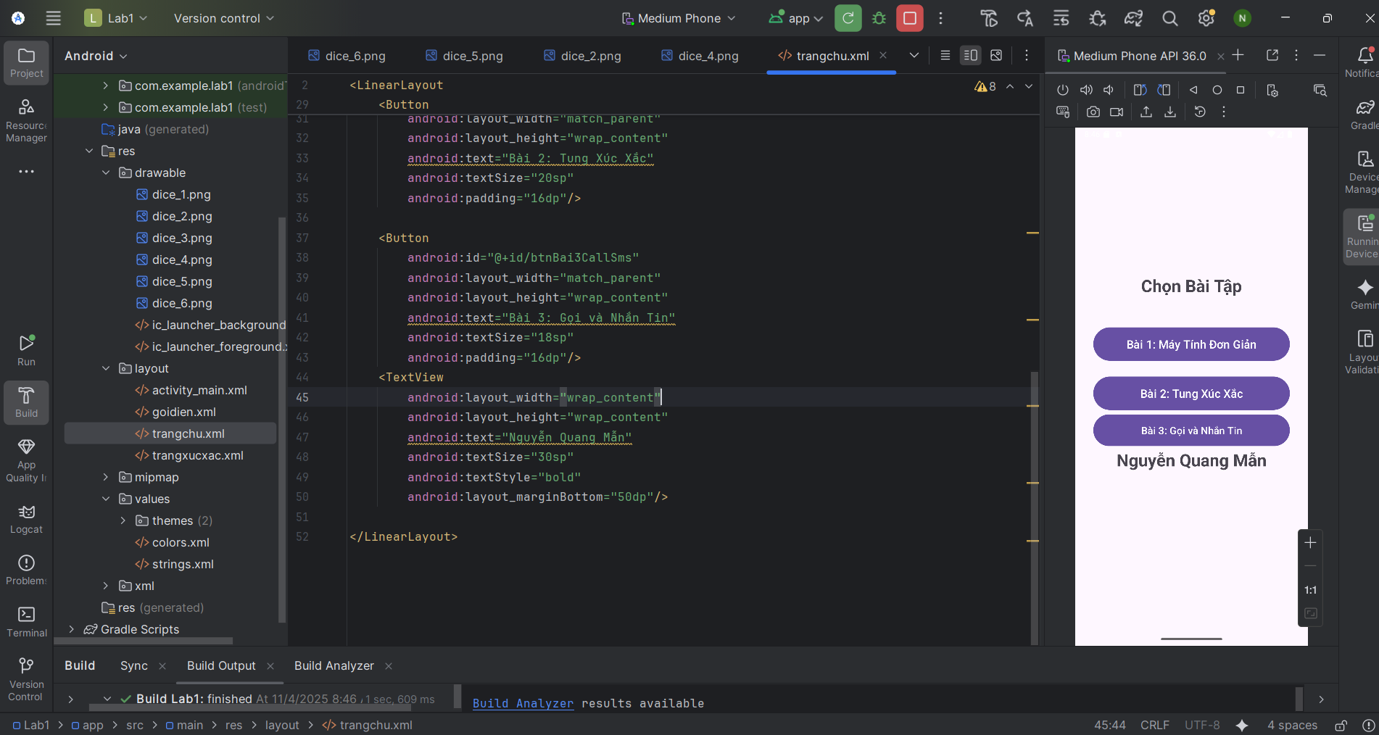

Bài 1:Máy tính cầm tay
Activity_main.xml
<?xml version="1.0" encoding="utf-8"?>
<LinearLayout
xmlns:android="http://schemas.android.com/apk/res/android"
xmlns:tools="http://schemas.android.com/tools"
android:layout_width="match_parent"
android:layout_height="match_parent"
android:orientation="vertical"
android:weightSum="10"
tools:context=".MainActivity">
<EditText
android:id="@+id/txtX"
android:layout_width="match_parent"
android:layout_height="0dp"
android:layout_weight="1"
android:gravity="center"
android:hint="@id/txtX"
android:inputType="numberDecimal" />
<EditText
android:id="@+id/txtY"
android:layout_width="match_parent"
android:layout_height="0dp"
android:layout_weight="1"
android:gravity="center"
android:hint="@id/txtY"
android:inputType="numberDecimal" />
<TextView
android:id="@+id/txtResult"
android:layout_width="match_parent"
android:layout_height="0dp"
android:layout_weight="1"
android:gravity="center"
android:text="@string/result"
android:textSize="24sp"
android:textStyle="bold" />
<LinearLayout
android:layout_width="match_parent"
android:layout_height="0dp"
android:layout_weight="1"
android:orientation="horizontal"
android:weightSum="5">
<Button
android:id="@+id/btnPlus"
android:layout_width="0dp"
android:layout_height="match_parent"
android:layout_weight="1"
android:text="@string/plus" />
<Button
android:id="@+id/btnMinus"
android:layout_width="0dp"
android:layout_height="match_parent"
android:layout_weight="1"
android:text="@string/minus" />
<Button
android:id="@+id/btnMultiply"
android:layout_width="0dp"
android:layout_height="match_parent"
android:layout_weight="1"
android:text="@string/multiply" />
<Button
android:id="@+id/btnDivide"
android:layout_width="0dp"
android:layout_height="match_parent"
android:layout_weight="1"
android:text="@string/divide" />
<Button
android:id="@+id/btnModulus"
android:layout_width="0dp"
android:layout_height="match_parent"
android:layout_weight="1"
android:text="@string/modulus" />
</LinearLayout>
<TextView
android:text="Nguyễn Quang Mẫn"
android:layout_width="match_parent"
android:layout_height="0dp"
android:layout_weight="1"
android:gravity="center"
android:textSize="24sp"
android:textStyle="bold" />
</LinearLayout>
MainActivity.java
package com.example.lab1;
import android.graphics.Color;
import android.os.Bundle;
import android.view.View;
import android.widget.Button;
import android.widget.EditText;
import android.widget.TextView;
import androidx.activity.EdgeToEdge;
import androidx.appcompat.app.AppCompatActivity;
import androidx.core.graphics.Insets;
import androidx.core.view.ViewCompat;
import androidx.core.view.WindowInsetsCompat;
public class MainActivity extends AppCompatActivity {
private EditText txtX, txtY;
private TextView txtResult;
private Button btnPlus, btnMinus, btnMul, btnDiv, btnMod;
@Override
protected void onCreate(Bundle savedInstanceState) {
super.onCreate(savedInstanceState);
EdgeToEdge.enable(this);
setContentView(R.layout.activity_main);
// Làm cho giao diện tràn viền và nằm sát dưới camera
getWindow().setStatusBarColor(Color.TRANSPARENT);
ViewCompat.setOnApplyWindowInsetsListener(findViewById(android.R.id.content), (v, insets) -> {
Insets systemBars = insets.getInsets(WindowInsetsCompat.Type.systemBars());
v.setPadding(0, 0, 0, 0); // loại bỏ padding mặc định
return insets;
});
initControl();
}
private void initControl() {
txtX = findViewById(R.id.txtX);
txtY = findViewById(R.id.txtY);
txtResult = findViewById(R.id.txtResult);
btnPlus = findViewById(R.id.btnPlus);
btnMinus = findViewById(R.id.btnMinus);
btnMul = findViewById(R.id.btnMultiply);
btnDiv = findViewById(R.id.btnDivide);
btnMod = findViewById(R.id.btnModulus);
// Tạo 1 listener chung cho 5 nút
View.OnClickListener listener = new View.OnClickListener() {
@Override
public void onClick(View view) {
try {
double x = Double.parseDouble(txtX.getText().toString());
double y = Double.parseDouble(txtY.getText().toString());
double result = 0;
int id = view.getId();
if (id == R.id.btnPlus) {
result = x + y;
} else if (id == R.id.btnMinus) {
result = x - y;
} else if (id == R.id.btnMultiply) {
result = x * y;
} else if (id == R.id.btnDivide) {
if (y == 0) {
txtResult.setText("Lỗi chia 0");
return;
}
result = x / y;
} else if (id == R.id.btnModulus) {
if (y == 0) {
txtResult.setText("Lỗi chia 0");
return;
}
result = x % y;
}
txtResult.setText(String.valueOf(result));
} catch (NumberFormatException e) {
txtResult.setText("Lỗi nhập số");
}
}
};
// Gắn sự kiện cho nút
btnPlus.setOnClickListener(listener);
btnMinus.setOnClickListener(listener);
btnMul.setOnClickListener(listener);
btnDiv.setOnClickListener(listener);
btnMod.setOnClickListener(listener);
}
}
String.xml
<resources>
<string name="app_name">Lab1</string>
<string name="result">Kết quả </string>
<string name="plus">+</string>
<string name="minus">-</string>
<string name="multiply">*</string>
<string name="divide">/</string>
<string name="modulus">%</string>
</resources>
Kết quả
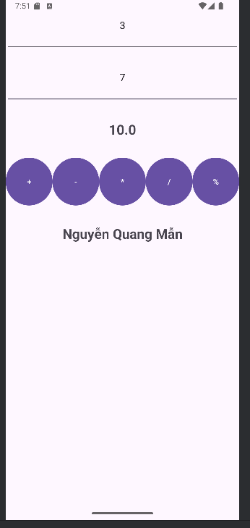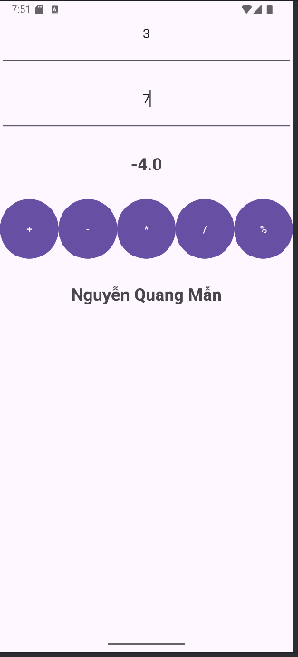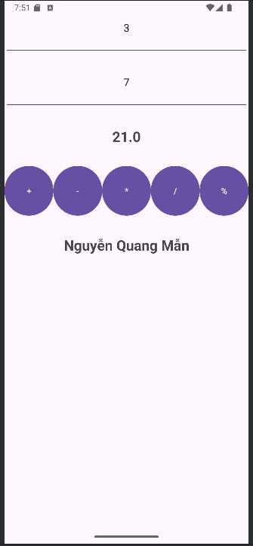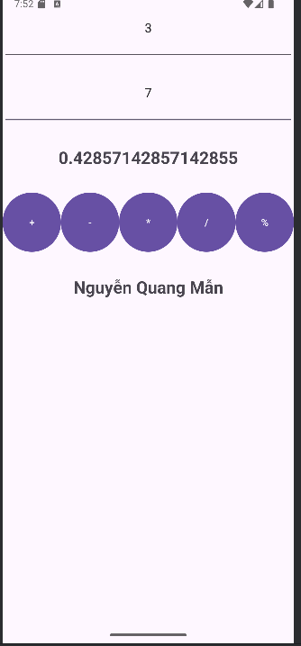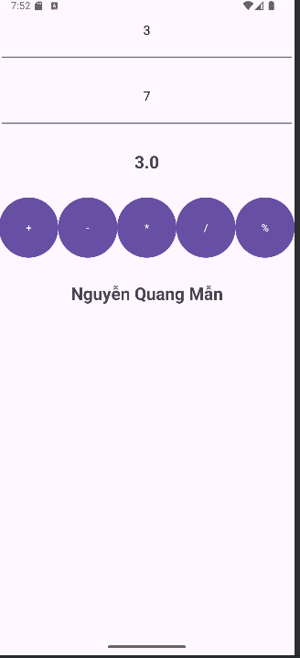

Bài 2:Xúc xắc
XucXac.java
package com.example.lab1;
import android.os.Bundle;
import android.view.View;
import android.widget.Button;
import android.widget.ImageView;
import android.widget.TextView;
import androidx.appcompat.app.AppCompatActivity;
import java.util.Random;
public class Xucxac extends AppCompatActivity {
private TextView txtDiceNumber;
private ImageView imgDice;
private Button btnRoll;
private final Random randomGenerator = new Random();
// Mảng chứa ID hình ảnh cho 6 mặt xúc xắc
private final int[] diceImages = {
R.drawable.dice_1,
R.drawable.dice_2,
R.drawable.dice_3,
R.drawable.dice_4,
R.drawable.dice_5,
R.drawable.dice_6
};
@Override
protected void onCreate(Bundle savedInstanceState) {
super.onCreate(savedInstanceState);
setContentView(R.layout.trangxucxac);
// Ánh xạ các control
txtDiceNumber = findViewById(R.id.txtDiceNumber);
imgDice = findViewById(R.id.imgDice);
btnRoll = findViewById(R.id.btnRoll);
// Thiết lập sự kiện cho nút "Tung Xúc Xắc"
btnRoll.setOnClickListener(new View.OnClickListener() {
@Override
public void onClick(View v) {
rollDice();
}
});
}
private void rollDice() {
// 1. Tạo số ngẫu nhiên từ 1 đến 6
int diceResult = randomGenerator.nextInt(6) + 1;
// 2. Cập nhật TextView hiển thị số xúc xắc
txtDiceNumber.setText(String.valueOf(diceResult));
// 3. Cập nhật hình xúc xắc tương ứng
int imageResourceId = diceImages[diceResult - 1];
imgDice.setImageResource(imageResourceId);
}
}
Trangxucxac.xml
<?xml version="1.0" encoding="utf-8"?>
<androidx.constraintlayout.widget.ConstraintLayout xmlns:android="http://schemas.android.com/apk/res/android"
xmlns:app="http://schemas.android.com/apk/res-auto"
android:layout_width="match_parent"
android:layout_height="match_parent"
android:padding="24dp">
<!-- Hiển thị số mặt xúc xắc -->
<TextView
android:id="@+id/txtDiceNumber"
android:layout_width="wrap_content"
android:layout_height="wrap_content"
android:text="0"
android:textColor="#F44336"
android:textSize="48sp"
app:layout_constraintTop_toTopOf="parent"
app:layout_constraintStart_toStartOf="parent"
app:layout_constraintEnd_toEndOf="parent"
app:layout_constraintBottom_toTopOf="@id/imgDice"
app:layout_constraintVertical_bias="0.2" />
<!-- Hình xúc xắc -->
<ImageView
android:id="@+id/imgDice"
android:layout_width="200dp"
android:layout_height="200dp"
android:src="@drawable/dice_1"
app:layout_constraintTop_toBottomOf="@id/txtDiceNumber"
app:layout_constraintBottom_toTopOf="@id/btnRoll"
app:layout_constraintStart_toStartOf="parent"
app:layout_constraintEnd_toEndOf="parent"
app:layout_constraintVertical_bias="0.4" />
<TextView
android:layout_width="wrap_content"
android:layout_height="wrap_content"
android:text="Nguyễn Quang Mẫn"/>
<!-- Nút tung xúc xắc -->
<Button
android:id="@+id/btnRoll"
android:layout_width="0dp"
android:layout_height="wrap_content"
android:text="TUNG XÚC XẮC"
android:backgroundTint="#03A9F4"
android:textColor="@android:color/white"
app:layout_constraintBottom_toBottomOf="parent"
app:layout_constraintStart_toStartOf="parent"
app:layout_constraintEnd_toEndOf="parent"
android:layout_margin="24dp" />
</androidx.constraintlayout.widget.ConstraintLayout>
Kết quả
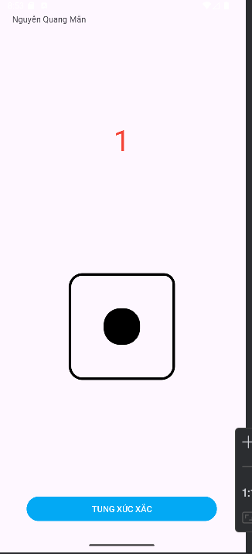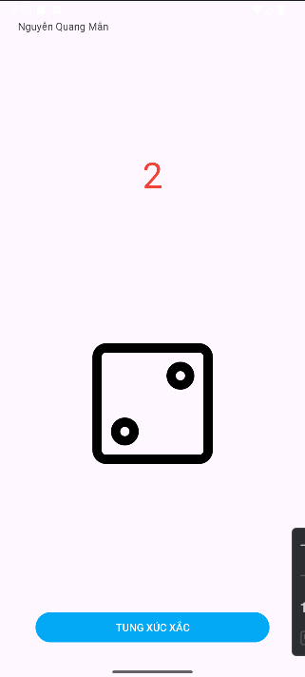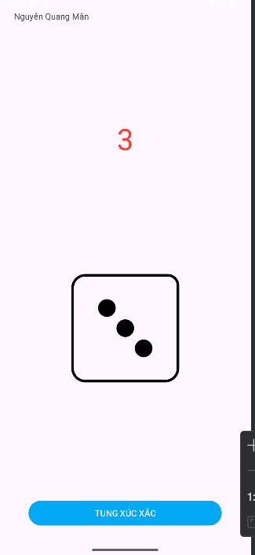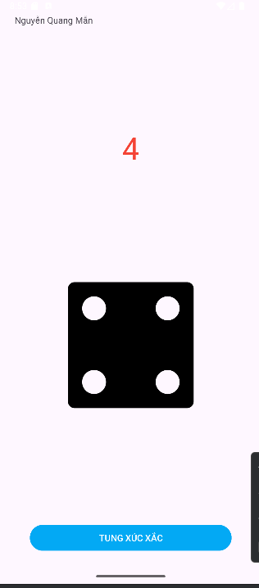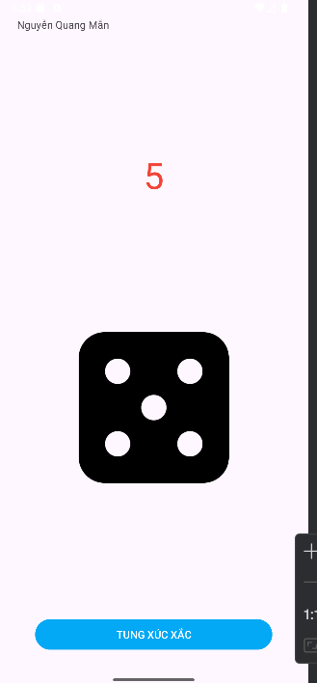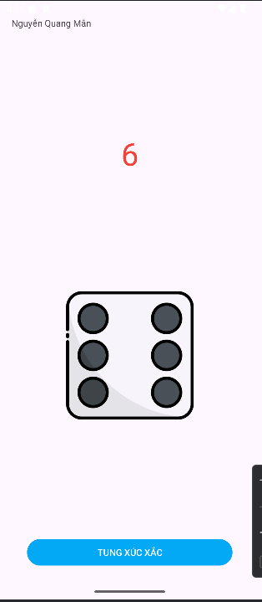

Bài 3:Gọi điện
Goidien.java
package com.example.lab1;
import androidx.annotation.NonNull;
import androidx.appcompat.app.AppCompatActivity;
import androidx.core.app.ActivityCompat;
import androidx.core.content.ContextCompat;
import android.Manifest;
import android.content.Intent;
import android.content.pm.PackageManager;
import android.net.Uri;
import android.os.Bundle;
import android.view.View;
import android.widget.Button;
import android.widget.EditText;
import android.widget.Toast;
public class Goidien extends AppCompatActivity {
private EditText edtPhoneNumber, edtMessage;
private Button btnCall, btnSMS;
private static final int REQUEST_CALL = 1;
@Override
protected void onCreate(Bundle savedInstanceState) {
super.onCreate(savedInstanceState);
setContentView(R.layout.goidien); // Giao diện riêng cho bài tập 3
// Ánh xạ view
edtPhoneNumber = findViewById(R.id.edtPhoneNumber);
edtMessage = findViewById(R.id.edtMessage);
btnCall = findViewById(R.id.btnCall);
btnSMS = findViewById(R.id.btnSMS);
// Xử lý nút gọi điện
btnCall.setOnClickListener(new View.OnClickListener() {
@Override
public void onClick(View v) {
makePhoneCall();
}
});
// Xử lý nút gửi SMS
btnSMS.setOnClickListener(new View.OnClickListener() {
@Override
public void onClick(View v) {
sendSMS();
}
});
}
// Hàm gọi điện
private void makePhoneCall() {
String number = edtPhoneNumber.getText().toString().trim();
if (number.isEmpty()) {
Toast.makeText(this, "Vui lòng nhập số điện thoại", Toast.LENGTH_SHORT).show();
return;
}
if (ContextCompat.checkSelfPermission(this, Manifest.permission.CALL_PHONE)
!= PackageManager.PERMISSION_GRANTED) {
ActivityCompat.requestPermissions(this,
new String[]{Manifest.permission.CALL_PHONE}, REQUEST_CALL);
} else {
String dial = "tel:" + number;
startActivity(new Intent(Intent.ACTION_CALL, Uri.parse(dial)));
}
}
// Hàm gửi tin nhắn
private void sendSMS() {
String number = edtPhoneNumber.getText().toString().trim();
String message = edtMessage.getText().toString().trim();
if (number.isEmpty() || message.isEmpty()) {
Toast.makeText(this, "Vui lòng nhập số và nội dung tin nhắn", Toast.LENGTH_SHORT).show();
return;
}
Intent intent = new Intent(Intent.ACTION_SENDTO);
intent.setData(Uri.parse("smsto:" + number)); // chỉ gửi SMS
intent.putExtra("sms_body", message);
startActivity(intent);
}
// Xử lý quyền gọi điện
@Override
public void onRequestPermissionsResult(int requestCode, @NonNull String[] permissions,
@NonNull int[] grantResults) {
super.onRequestPermissionsResult(requestCode, permissions, grantResults);
if (requestCode == REQUEST_CALL) {
if (grantResults.length > 0 && grantResults[0] == PackageManager.PERMISSION_GRANTED) {
makePhoneCall();
} else {
Toast.makeText(this, "Quyền gọi điện bị từ chối", Toast.LENGTH_SHORT).show();
}
}
}
}
Goidien.xml
<?xml version="1.0" encoding="utf-8"?>
<LinearLayout xmlns:android="http://schemas.android.com/apk/res/android"
android:layout_width="match_parent"
android:layout_height="match_parent"
android:orientation="vertical"
android:padding="24dp"
android:gravity="center">
<TextView
android:layout_width="wrap_content"
android:layout_height="wrap_content"
android:text="Nguyễn Quang Mẫn"/>
<EditText
android:id="@+id/edtPhoneNumber"
android:layout_width="match_parent"
android:layout_height="wrap_content"
android:hint="Nhập số điện thoại"
android:inputType="phone"
android:textSize="18sp" />
<EditText
android:id="@+id/edtMessage"
android:layout_width="match_parent"
android:layout_height="wrap_content"
android:hint="Nhập nội dung tin nhắn"
android:inputType="textMultiLine"
android:lines="3"
android:gravity="top"
android:textSize="18sp"
android:layout_marginTop="12dp" />
<Button
android:id="@+id/btnCall"
android:layout_width="match_parent"
android:layout_height="wrap_content"
android:text="📞 GỌI ĐIỆN"
android:backgroundTint="#4CAF50"
android:textColor="@android:color/white"
android:layout_marginTop="20dp" />
<Button
android:id="@+id/btnSMS"
android:layout_width="match_parent"
android:layout_height="wrap_content"
android:text="💬 GỬI SMS"
android:backgroundTint="#03A9F4"
android:textColor="@android:color/white"
android:layout_marginTop="12dp" />
</LinearLayout>
Kết quả
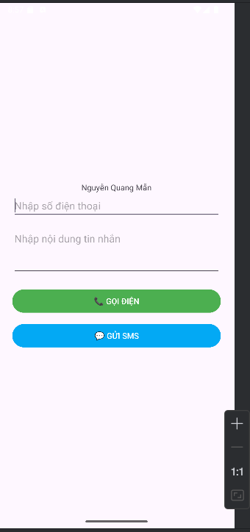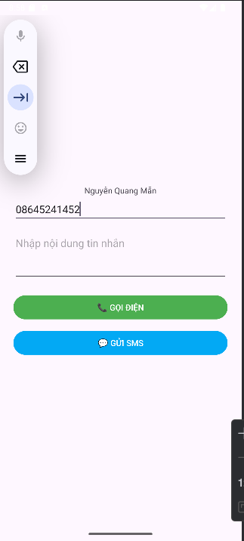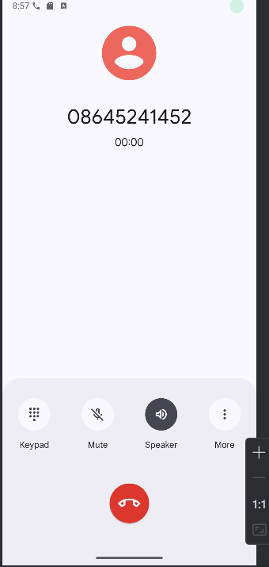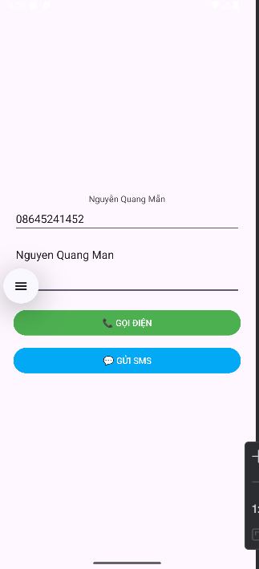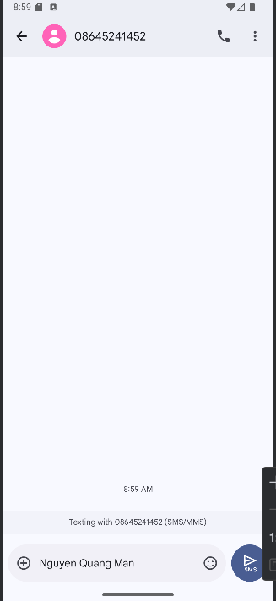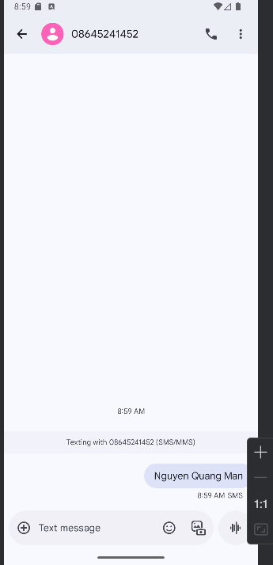

B.Lab2

1.Tạo trang chủ để liên kết các trang
Trang chủ
AndroidManifest.xml
<?xml version="1.0" encoding="utf-8"?>
<manifest xmlns:android="http://schemas.android.com/apk/res/android">
<application
android:allowBackup="true"
android:icon="@mipmap/ic_launcher"
android:label="@string/app_name"
android:supportsRtl="true"
android:theme="@style/Theme.AppCompat.Light.NoActionBar">
<activity android:name=".Bai3Activity" android:exported="true" />
<activity android:name=".Bai2Activity" android:exported="true" />
<activity android:name=".Bai1Activity" android:exported="true" />
<activity
android:name=".MainActivity"
android:exported="true">
<intent-filter>
<action android:name="android.intent.action.MAIN" />
<category android:name="android.intent.category.LAUNCHER" />
</intent-filter>
</activity>
</application>
</manifest>
MainActivity.java
package com.example.uidesign;
import android.content.Intent;
import android.os.Bundle;
import android.widget.Button;
import androidx.appcompat.app.AppCompatActivity;
public class MainActivity extends AppCompatActivity {
@Override
protected void onCreate(Bundle savedInstanceState) {
super.onCreate(savedInstanceState);
setContentView(R.layout.activity_main);
Button btn1 = findViewById(R.id.btnBai1);
Button btn2 = findViewById(R.id.btnBai2);
Button btn3 = findViewById(R.id.btnBai3);
btn1.setOnClickListener(v -> startActivity(new Intent(this, Bai1Activity.class)));
btn2.setOnClickListener(v -> startActivity(new Intent(this, Bai2Activity.class)));
btn3.setOnClickListener(v -> startActivity(new Intent(this, Bai3Activity.class)));
}
}
activity_main.xml
<LinearLayout xmlns:android="http://schemas.android.com/apk/res/android"
android:layout_width="match_parent"
android:layout_height="match_parent"
android:gravity="center"
android:orientation="vertical"
android:padding="24dp">
<TextView
android:layout_width="wrap_content"
android:layout_height="wrap_content"
android:text="Nguyễn Quang Mẫn"/>
<Button
android:id="@+id/btnBai1"
android:layout_width="match_parent"
android:layout_height="wrap_content"
android:text="Bài 1: Màu nền và Icon ngẫu nhiên" />
<Button
android:id="@+id/btnBai2"
android:layout_width="match_parent"
android:layout_height="wrap_content"
android:text="Bài 2: Trang Loangding"
android:layout_marginTop="16dp"/>
<Button
android:id="@+id/btnBai3"
android:layout_width="match_parent"
android:layout_height="wrap_content"
android:text="Bài 3: Gọi điện Intent"
android:layout_marginTop="16dp"/>
</LinearLayout>
Kết quả
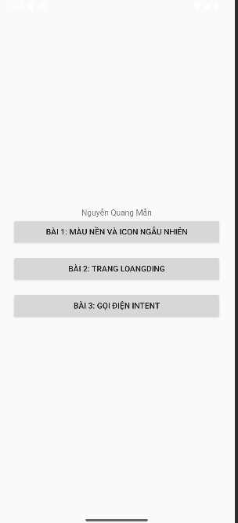

Bài 1: Hiện icon và màu nền khác nhau khi nhấp vào
Bai1Activity.java
package com.example.uidesign;
import android.os.Bundle;
import android.widget.ImageView;
import android.widget.LinearLayout;
import androidx.appcompat.app.AppCompatActivity;
import java.util.Random;
public class Bai1Activity extends AppCompatActivity {
int[] colors = {
0xFFFFCDD2, 0xFFC8E6C9, 0xFFBBDEFB, 0xFFFFF9C4, 0xFFD1C4E9
};
int[] icons = {
R.drawable.img_1,
R.drawable.img_3,
R.drawable.img_4,
R.drawable.favourite,
R.drawable.img
};
@Override
protected void onCreate(Bundle savedInstanceState) {
super.onCreate(savedInstanceState);
setContentView(R.layout.activity_bai1);
LinearLayout layout = findViewById(R.id.layoutBai1);
ImageView imageView = findViewById(R.id.random_icon);
Random random = new Random();
int color = colors[random.nextInt(colors.length)];
int icon = icons[random.nextInt(icons.length)];
layout.setBackgroundColor(color);
imageView.setImageResource(icon);
}
}
actitivity_bai1.xml
<LinearLayout xmlns:android="http://schemas.android.com/apk/res/android"
android:id="@+id/layoutBai1"
android:layout_width="match_parent"
android:layout_height="match_parent"
android:gravity="center"
android:orientation="vertical">
<TextView
android:layout_width="wrap_content"
android:layout_height="wrap_content"
android:text="Nguyễn Quang Mẫn"/>
<ImageView
android:id="@+id/random_icon"
android:layout_width="150dp"
android:layout_height="150dp"
android:contentDescription="random icon" />
</LinearLayout>
Kết quả
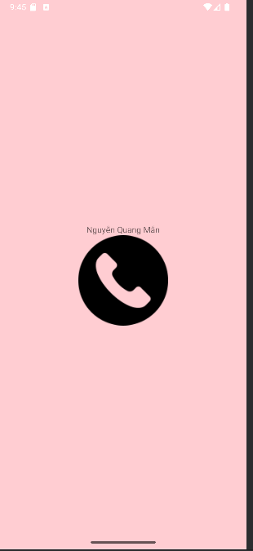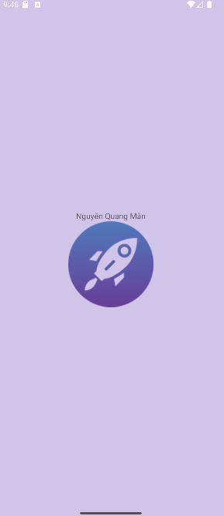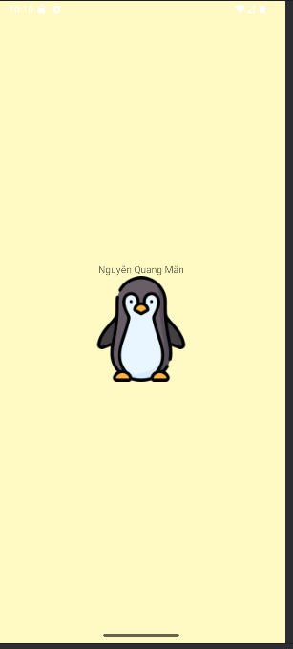

Bài 2: Trang loading
Bai2Activity.java
package com.example.uidesign;
import android.os.Bundle;
import androidx.appcompat.app.AppCompatActivity;
public class Bai2Activity extends AppCompatActivity {
@Override
protected void onCreate(Bundle savedInstanceState) {
super.onCreate(savedInstanceState);
setContentView(R.layout.activity_bai2);
}
}
activity_bai2.xml
<LinearLayout xmlns:android="http://schemas.android.com/apk/res/android"
android:layout_width="match_parent"
android:layout_height="match_parent"
android:gravity="center"
android:orientation="vertical"
android:background="#222">
<ProgressBar
android:layout_width="100dp"
android:layout_height="100dp"
android:indeterminate="true"
android:indeterminateDrawable="@drawable/custom_progress" />
<TextView
android:layout_width="wrap_content"
android:layout_height="wrap_content"
android:text="Đang tải..."
android:textColor="@android:color/white"
android:layout_marginTop="16dp"/>
<TextView
android:layout_width="wrap_content"
android:layout_height="wrap_content"
android:text="Nguyễn Quang Mẫn"
android:textColor="@android:color/white"
android:layout_marginTop="16dp"/>
</LinearLayout>
Kết quả
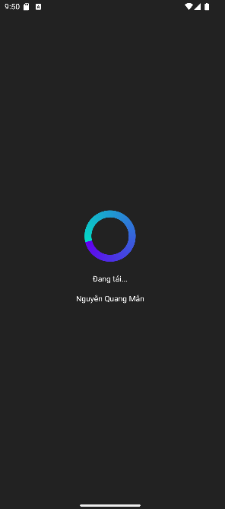

Bài 3: Trang cá nhân và gọi điện
Bai3Activity.java
package com.example.uidesign;
import android.content.Intent;
import android.net.Uri;
import android.os.Bundle;
import android.widget.ImageView;
import androidx.appcompat.app.AppCompatActivity;
public class Bai3Activity extends AppCompatActivity {
@Override
protected void onCreate(Bundle savedInstanceState) {
super.onCreate(savedInstanceState);
setContentView(R.layout.activity_bai3);
ImageView callIcon = findViewById(R.id.call_icon);
callIcon.setOnClickListener(v -> {
Intent intent = new Intent(Intent.ACTION_DIAL);
intent.setData(Uri.parse("tel:0901234567"));
startActivity(intent);
});
}
}
activity_bai3.xml
<?xml version="1.0" encoding="utf-8"?>
<LinearLayout xmlns:android="http://schemas.android.com/apk/res/android"
xmlns:app="http://schemas.android.com/apk/res-auto"
xmlns:tools="http://schemas.android.com/tools"
android:layout_width="match_parent"
android:layout_height="match_parent"
android:orientation="vertical"
android:background="@color/gray_light"
tools:context=".Bai3Activity">
<!-- ẢNH ĐẠI DIỆN VÀ TÊN -->
<FrameLayout
android:layout_width="match_parent"
android:layout_height="350dp">
<ImageView
android:layout_width="match_parent"
android:layout_height="300dp"
android:scaleType="centerCrop"
android:src="@drawable/img"
tools:ignore="ContentDescription" />
<TextView
android:layout_width="wrap_content"
android:layout_height="wrap_content"
android:layout_gravity="bottom"
android:layout_marginStart="70dp"
android:layout_marginBottom="90dp"
android:fontFamily="sans-serif"
android:text="@string/txt_name"
android:textColor="@color/black"
android:textSize="40sp" />
<!-- ICON GỌI ĐIỆN NỔI -->
<ImageView
android:layout_width="80dp"
android:layout_height="80dp"
android:layout_gravity="end|bottom"
android:layout_marginEnd="20dp"
android:layout_marginBottom="10dp"
android:background="@drawable/bg_oval"
android:padding="20dp"
android:src="@drawable/img_2"
app:tint="@color/white"/>
</FrameLayout>
<!-- DANH SÁCH THÔNG TIN LIÊN HỆ -->
<TableRow
android:layout_width="match_parent"
android:layout_height="wrap_content"
android:padding="20dp">
<ImageView
android:id="@+id/call_icon"
android:layout_width="60dp"
android:layout_height="60dp"
android:padding="10dp"
android:src="@drawable/img_3"
app:tint="@color/indigo"
tools:ignore="ContentDescription"
android:contentDescription="Call"/>
<LinearLayout
android:layout_width="match_parent"
android:layout_height="wrap_content"
android:layout_marginStart="30dp"
android:orientation="vertical">
<TextView
android:layout_width="match_parent"
android:layout_height="wrap_content"
android:text="@string/txt_phone1"
android:textColor="@color/gray_dark"
android:textSize="20sp" />
<TextView
android:layout_width="match_parent"
android:layout_height="wrap_content"
android:layout_marginTop="5dp"
android:text="@string/txt_title_mobile"
android:textColor="@color/gray_mid"
android:textSize="18sp" />
<TextView
android:layout_width="match_parent"
android:layout_height="wrap_content"
android:layout_marginTop="30dp"
android:text="@string/txt_phone2"
android:textColor="@color/gray_dark"
android:textSize="20sp" />
<TextView
android:layout_width="match_parent"
android:layout_height="wrap_content"
android:layout_marginTop="5dp"
android:text="@string/txt_title_mobile"
android:textColor="@color/gray_mid"
android:textSize="18sp" />
<View
android:layout_width="match_parent"
android:layout_height="0.5dp"
android:layout_marginTop="30dp"
android:background="@color/gray_mid" />
</LinearLayout>
</TableRow>
<TableRow
android:layout_width="match_parent"
android:layout_height="wrap_content"
android:padding="20dp">
<ImageView
android:layout_width="60dp"
android:layout_height="60dp"
android:padding="10dp"
android:src="@drawable/img_4"
app:tint="@color/indigo"
tools:ignore="ContentDescription" />
<LinearLayout
android:layout_width="match_parent"
android:layout_height="match_parent"
android:layout_marginStart="30dp"
android:orientation="vertical">
<TextView
android:layout_width="match_parent"
android:layout_height="wrap_content"
android:text="@string/txt_email"
android:textColor="@color/gray_dark"
android:textSize="20sp" />
<TextView
android:layout_width="match_parent"
android:layout_height="wrap_content"
android:layout_marginTop="5dp"
android:text="@string/txt_title_mobile"
android:textColor="@color/gray_mid"
android:textSize="18sp" />
</LinearLayout>
</TableRow>
</LinearLayout>
Colors.xml
<?xml version="1.0" encoding="utf-8"?>
<resources>
<color name="purple_200">#FFBB86FC</color>
<color name="purple_500">#FF6200EE</color>
<color name="purple_700">#FF03DAC5</color>
<color name="teal_200">#FF03DAC5</color>
<color name="teal_500">#FF03DAC5</color>
<color name="black">#FF000000</color>
<color name="white">#FFFFFFFF</color>
<color name="green">#FF00FF00</color>
<color name="gray_mid">#979797</color>
<color name="gray_dark">#535353</color>
<color name="indigo">#424FB7</color>
<color name="gray_light">#FAFAFA</color>
</resources>
Strings.xml
<resources>
<string name="app_name">Animal Sound</string>
<string name="txt_name">Nguyễn Quang Mẫn</string>
<string name="txt_phone1">0901234567</string>
<string name="txt_title_mobile">Mobile</string>
<string name="txt_phone2">092834982982</string>
<string name="txt_email">aliconnors@example.com</string>
Kết quả
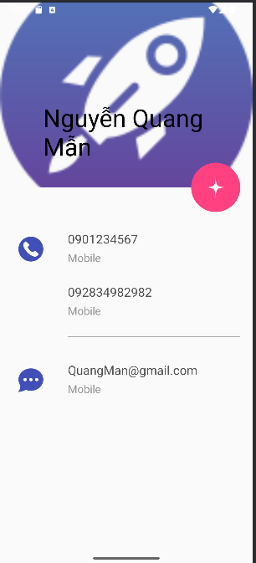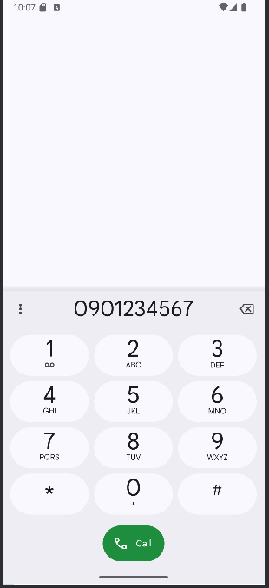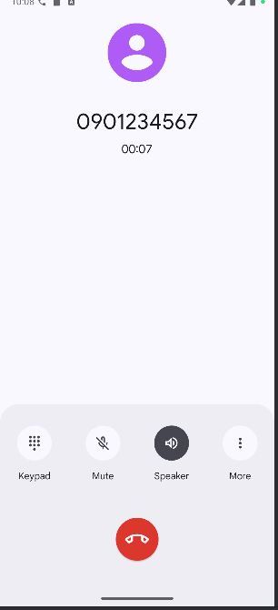

C.Lab3

Bài 1:Chương trình đổi tiền tệ
AndroidManifest.xml
<?xml version="1.0" encoding="utf-8"?>
<manifest xmlns:android="http://schemas.android.com/apk/res/android"
xmlns:tools="http://schemas.android.com/tools">
<application
android:allowBackup="true"
android:dataExtractionRules="@xml/data_extraction_rules"
android:fullBackupContent="@xml/backup_rules"
android:icon="@mipmap/ic_launcher"
android:label="@string/app_name"
android:roundIcon="@mipmap/ic_launcher_round"
android:supportsRtl="true"
android:theme="@style/Theme.Lab3">
<activity android:name=".MainActivity" />
<activity android:name=".LengthActivity" />
<activity android:name=".Bai3Activity" />
<activity android:name=".rgb"/>
<activity android:name=".HomeActivity"
android:exported="true">
<intent-filter>
<action android:name="android.intent.action.MAIN" />
<category android:name="android.intent.category.LAUNCHER" />
</intent-filter>
</activity>
</application>
</manifest>

Bai3Activity.java
package com.example.lab3;
import android.app.Dialog;
import android.os.Bundle;
import android.view.Gravity;
import android.view.LayoutInflater;
import android.view.View;
import android.widget.*;
import androidx.appcompat.app.AppCompatActivity;
public class Bai3Activity extends AppCompatActivity {
Button btnToast, btnDialog;
@Override
protected void onCreate(Bundle savedInstanceState) {
super.onCreate(savedInstanceState);
setContentView(R.layout.bai7);
btnToast = findViewById(R.id.btnToast);
btnDialog = findViewById(R.id.btnDialog);
// ===== CUSTOM TOAST =====
btnToast.setOnClickListener(v -> showCustomToast());
// ===== CUSTOM DIALOG =====
btnDialog.setOnClickListener(v -> showLoginDialog());
}
// ---------------- CUSTOM TOAST ----------------
private void showCustomToast() {
LayoutInflater inflater = getLayoutInflater();
View layout = inflater.inflate(R.layout.custom_toast, null);
TextView txt = layout.findViewById(R.id.txtToastMsg);
txt.setText("Custom Toast, made by Duy Quy");
Toast toast = new Toast(getApplicationContext());
toast.setDuration(Toast.LENGTH_LONG);
toast.setGravity(Gravity.CENTER_HORIZONTAL | Gravity.CENTER_VERTICAL, 0, 200);
toast.setView(layout);
toast.show();
}
// ---------------- CUSTOM DIALOG ----------------
private void showLoginDialog() {
Dialog dialog = new Dialog(Bai3Activity.this);
dialog.setContentView(R.layout.dialog_login);
EditText txtUser = dialog.findViewById(R.id.txtUser);
EditText txtPass = dialog.findViewById(R.id.txtPass);
Button btnOK = dialog.findViewById(R.id.btnOK);
Button btnCancel = dialog.findViewById(R.id.btnCancel);
btnOK.setOnClickListener(v -> {
String u = txtUser.getText().toString().trim();
String p = txtPass.getText().toString().trim();
if (u.equals("admin") && p.equals("123")) {
showSuccessToast("Đăng nhập thành công!");
dialog.dismiss();
} else {
showSuccessToast("Sai tài khoản hoặc mật khẩu!");
}
});
btnCancel.setOnClickListener(v -> dialog.dismiss());
dialog.show();
}
// Toast tái sử dụng
private void showSuccessToast(String message) {
LayoutInflater inflater = getLayoutInflater();
View layout = inflater.inflate(R.layout.custom_toast, null);
TextView txt = layout.findViewById(R.id.txtToastMsg);
txt.setText(message);
Toast toast = new Toast(getApplicationContext());
toast.setDuration(Toast.LENGTH_SHORT);
toast.setGravity(Gravity.CENTER_HORIZONTAL | Gravity.CENTER_VERTICAL, 0, 200);
toast.setView(layout);
toast.show();
}
}
CurrencyAdapter.java
package com.example.lab3;
import android.content.Context;
import android.view.*;
import android.widget.*;
public class CurrencyAdapter extends BaseAdapter {
Context context;
int[] flags;
String[] codes;
double[] values;
LayoutInflater inflater;
public CurrencyAdapter(Context context, int[] flags, String[] codes, double[] values) {
this.context = context;
this.flags = flags;
this.codes = codes;
this.values = values;
inflater = LayoutInflater.from(context);
}
@Override
public int getCount() {
return codes.length;
}
@Override
public Object getItem(int i) {
return codes[i];
}
@Override
public long getItemId(int i) {
return i;
}
@Override
public View getView(int i, View convertView, ViewGroup parent) {
convertView = inflater.inflate(R.layout.item_currency, null);
ImageView img = convertView.findViewById(R.id.imgFlag);
TextView txtCode = convertView.findViewById(R.id.txtCode);
TextView txtValue = convertView.findViewById(R.id.txtValue);
img.setImageResource(flags[i]);
txtCode.setText(codes[i]);
txtValue.setText(String.format("%.5f", values[i]));
return convertView;
}
}
HomeActivity.java
package com.example.lab3;
import androidx.appcompat.app.AppCompatActivity;
import android.os.Bundle;
import android.widget.Button;
import android.content.Intent;
public class HomeActivity extends AppCompatActivity {
Button btnMoney, btnLength, btnBai3,btnBai4, btnExit;
@Override
protected void onCreate(Bundle savedInstanceState) {
super.onCreate(savedInstanceState);
setContentView(R.layout.activity_home);
btnMoney = findViewById(R.id.btnMoney);
btnLength = findViewById(R.id.btnLength);
btnBai3 = findViewById(R.id.btnBai3);
btnBai4 = findViewById(R.id.btnBai4);
btnExit = findViewById(R.id.btnExit);
// Bài 1: Đổi tiền
btnMoney.setOnClickListener(v ->
startActivity(new Intent(HomeActivity.this, MainActivity.class))
);
// Bài 2: Đổi độ dài
btnLength.setOnClickListener(v ->
startActivity(new Intent(HomeActivity.this, LengthActivity.class))
);
// Bài 3: RGB – CMY Seekbar
btnBai3.setOnClickListener(v ->
startActivity(new Intent(HomeActivity.this, Bai3Activity.class))
);
btnBai4.setOnClickListener(v ->
startActivity(new Intent(HomeActivity.this, rgb.class))
);
// Thoát app
btnExit.setOnClickListener(v -> finishAffinity());
}
}
LengthActivity.java
package com.example.lab3;
import androidx.appcompat.app.AppCompatActivity;
import android.os.Bundle;
import android.text.Editable;
import android.text.TextWatcher;
import android.widget.*;
import android.view.Menu;
import android.view.MenuItem;
import android.content.Intent;
import com.google.android.material.appbar.MaterialToolbar;
import org.jspecify.annotations.NonNull;
public class LengthActivity extends AppCompatActivity {
EditText txtNumber;
Spinner spnUnit;
ListView listViewLength;
// Tên đơn vị
String[] unitNames = {
"Hải lý", "Dặm", "Kilometer", "Lý",
"Met", "Yard", "Foot", "Inches"
};
// MA TRẬN TỈ LỆ (8×8)
double[][] rate = {
{1.0, 1.15077945, 1.852, 20.2537183, 1852, 2025.37183, 6076.11549, 72913.38583},
{0.86897624, 1.0, 1.609344, 17.60, 1609.344, 1760.0, 5280.0, 63360},
{0.53995680, 0.62137119, 1.0, 10.9361330, 1000.0, 1093.61330, 3280.83990, 39370.07874},
{0.04937365, 0.05681818, 0.0914400, 1.0000, 91.44, 100.0, 300.0, 3600.0},
{0.00053996, 0.00062137, 0.0010000, 0.0109361, 1.0, 1.09361, 3.28084, 39.37008},
{0.00049374, 0.00056818, 0.0009440, 0.01000, 0.9144, 1.0, 3.0, 36.0},
{0.00016458, 0.00018939, 0.00030843, 0.0033333, 0.3048, 0.33333, 1.0, 12.0},
{0.00001371, 0.00001578, 0.0000254, 0.0002778, 0.0254, 0.02778, 0.08333, 1.0}
};
@Override
protected void onCreate(Bundle savedInstanceState) {
super.onCreate(savedInstanceState);
setContentView(R.layout.activity_length);
txtNumber = findViewById(R.id.txtNumber);
spnUnit = findViewById(R.id.spnUnit);
listViewLength = findViewById(R.id.listViewLength);
// Spinner
ArrayAdapter<String> adapter =
new ArrayAdapter<>(this, android.R.layout.simple_spinner_item, unitNames);
adapter.setDropDownViewResource(android.R.layout.simple_spinner_dropdown_item);
spnUnit.setAdapter(adapter);
txtNumber.addTextChangedListener(textWatcher);
spnUnit.setOnItemSelectedListener(spListener);
updateList();
MaterialToolbar topAppBar = findViewById(R.id.topAppBar);
setSupportActionBar(topAppBar);
}
TextWatcher textWatcher = new TextWatcher() {
@Override
public void beforeTextChanged(CharSequence s, int start, int count, int after) {
}
@Override
public void onTextChanged(CharSequence s, int start, int before, int count) {
updateList();
}
@Override
public void afterTextChanged(Editable s) {
}
};
AdapterView.OnItemSelectedListener spListener = new AdapterView.OnItemSelectedListener() {
@Override
public void onItemSelected(AdapterView<?> parent, android.view.View view, int pos, long id) {
updateList();
}
@Override
public void onNothingSelected(AdapterView<?> parent) {
}
};
void updateList() {
double val = 0;
try {
val = Double.parseDouble(txtNumber.getText().toString());
} catch (Exception ignored) {
}
int from = spnUnit.getSelectedItemPosition();
double[] results = new double[unitNames.length];
for (int i = 0; i < results.length; i++) {
results[i] = val * rate[from][i];
}
LengthAdapter adapter = new LengthAdapter(this, unitNames, results);
listViewLength.setAdapter(adapter);
}
@Override
public boolean onCreateOptionsMenu(Menu menu) {
getMenuInflater().inflate(R.menu.main_menu, menu);
return true;
}
@Override
public boolean onOptionsItemSelected(@NonNull MenuItem item) {
int id = item.getItemId();
if (id == R.id.menu_money) {
startActivity(new Intent(LengthActivity.this, MainActivity.class));
return true;
}
if (id == R.id.menu_length) {
return true;
}
return super.onOptionsItemSelected(item);
}
}

Strings.xml
<resources>
<string name="app_name">Chương trình đổi tiền</string>

<string name="author">Họ tên SV</string>
<string name="computer">Tên máy</string>
<string name="textbox_hint">Nhập số tiền</string>

<!-- Tên tiền tệ -->
<string name="usd_name">American Dollar</string>
<string name="eur_name">European Cash</string>
<string name="gbp_name">Great Britain</string>
<string name="aud_name">Australia Dollar</string>
<string name="cad_name">Canadian Dollar</string>
<string name="zar_name">South Africa Rand</string>
<string name="nzd_name">New Zealand Dollar</string>
<string name="vnd_name">Việt Nam Đồng</string>
<string name="inr_name">Indian Rupe</string>
<string name="jpy_name">Yên Nhật</string>

<!-- Đơn vị tiền -->
<string name="usd_unit">USD</string>
<string name="eur_unit">EUR</string>
<string name="gbp_unit">GBP</string>
<string name="inr_unit">INR</string>
<string name="aud_unit">AUD</string>
<string name="cad_unit">CAD</string>
<string name="zar_unit">ZAR</string>
<string name="nzd_unit">NZD</string>
<string name="jpy_unit">JPY</string>
<string name="vnd_unit">VND</string>
</resources>
Activitymain.xml
<?xml version="1.0" encoding="utf-8"?>
<LinearLayout xmlns:android="http://schemas.android.com/apk/res/android"
android:orientation="vertical"
android:padding="10dp"
android:layout_width="match_parent"
android:layout_height="match_parent">
<!-- NHẬP SỐ + SPINNER -->
<LinearLayout
android:layout_width="match_parent"
android:layout_height="wrap_content"
android:orientation="horizontal">
<EditText
android:id="@+id/txtNumber"
android:layout_width="0dp"
android:layout_weight="1"
android:layout_height="wrap_content"
android:hint="@string/textbox_hint"
android:inputType="numberDecimal"
android:textSize="20sp"/>
<Spinner
android:id="@+id/spnUnit"
android:layout_width="wrap_content"
android:layout_height="wrap_content"
android:paddingStart="10dp"/>
</LinearLayout>
<!-- DANH SÁCH KẾT QUẢ -->
<ListView
android:id="@+id/listViewRate"
android:layout_width="match_parent"
android:layout_height="match_parent"/>
</LinearLayout>
CurrencyAdapter.java
package com.example.lab3;
import android.content.Context;
import android.view.*;
import android.widget.*;
public class CurrencyAdapter extends BaseAdapter {
Context context;
int[] flags;
String[] codes;
double[] values;
LayoutInflater inflater;
public CurrencyAdapter(Context context, int[] flags, String[] codes, double[] values) {
this.context = context;
this.flags = flags;
this.codes = codes;
this.values = values;
inflater = LayoutInflater.from(context);
}
@Override
public int getCount() {
return codes.length;
}
@Override
public Object getItem(int i) {
return codes[i];
}
@Override
public long getItemId(int i) {
return i;
}
@Override
public View getView(int i, View convertView, ViewGroup parent) {
convertView = inflater.inflate(R.layout.item_currency, null);
ImageView img = convertView.findViewById(R.id.imgFlag);
TextView txtCode = convertView.findViewById(R.id.txtCode);
TextView txtValue = convertView.findViewById(R.id.txtValue);
img.setImageResource(flags[i]);
txtCode.setText(codes[i]);
txtValue.setText(String.format("%.5f", values[i]));
return convertView;
}
}
MainActivity.java
package com.example.lab3;
import androidx.appcompat.app.AppCompatActivity;
import android.os.Bundle;
import android.text.*;
import android.widget.*;
public class MainActivity extends AppCompatActivity {
EditText txtNumber;
Spinner spnUnit;
ListView listViewRate;
String[] codes = {"USD", "EUR", "GBP", "INR", "AUD", "CAD", "ZAR", "NZD", "JPY"};
int[] flags = {
R.drawable.america,
R.drawable.eu,
R.drawable.england,
R.drawable.india,
R.drawable.australia,
R.drawable.canada,
R.drawable.southafrica,
R.drawable.newzealand,
R.drawable.japan
};
double[][] rate = {
{1, 0.91, 0.79, 83, 1.48, 1.36, 18.30, 1.64, 148},
{1.09, 1, 0.86, 92, 1.62, 1.48, 20.10, 1.78, 162},
{1.27, 1.16, 1, 105, 1.88, 1.71, 23, 2.10, 185},
{0.012, 0.011, 0.0095, 1, 0.018, 0.016, 0.22, 0.019, 1.76},
{0.68, 0.62, 0.53, 56, 1, 0.91, 12, 1.12, 98},
{0.73, 0.67, 0.58, 60, 1.10, 1, 13.1, 1.20, 103},
{0.055, 0.049, 0.043, 4.6, 0.083, 0.076, 1, 0.092, 8.3},
{0.61, 0.56, 0.48, 52, 0.89, 0.83, 10.8, 1, 92},
{0.0068, 0.0061, 0.0054, 0.57, 0.010, 0.0096, 0.12, 0.010, 1}
};
@Override
protected void onCreate(Bundle savedInstanceState) {
super.onCreate(savedInstanceState);
setContentView(R.layout.activity_main);
txtNumber = findViewById(R.id.txtNumber);
spnUnit = findViewById(R.id.spnUnit);
listViewRate = findViewById(R.id.listViewRate);
ArrayAdapter<String> adapter =
new ArrayAdapter<>(this, android.R.layout.simple_spinner_item, codes);
adapter.setDropDownViewResource(android.R.layout.simple_spinner_dropdown_item);
spnUnit.setAdapter(adapter);
txtNumber.addTextChangedListener(textWatcher);
spnUnit.setOnItemSelectedListener(spinnerListener);
updateList();
}
TextWatcher textWatcher = new TextWatcher() {
@Override public void beforeTextChanged(CharSequence s, int start, int count, int after) {}
@Override public void onTextChanged(CharSequence s, int start, int before, int count) {
updateList();
}
@Override public void afterTextChanged(Editable s) {}
};
AdapterView.OnItemSelectedListener spinnerListener = new AdapterView.OnItemSelectedListener() {
@Override
public void onItemSelected(AdapterView<?> parent, android.view.View view, int position, long id) {
updateList();
}
@Override public void onNothingSelected(AdapterView<?> parent) {}
};
void updateList() {
double val = 0;
try {
val = Double.parseDouble(txtNumber.getText().toString());
} catch (Exception e) {}
int from = spnUnit.getSelectedItemPosition();
double[] results = new double[codes.length];
for (int i = 0; i < results.length; i++) {
results[i] = val * rate[from][i];
}
CurrencyAdapter adapter = new CurrencyAdapter(this, flags, codes, results);
listViewRate.setAdapter(adapter);
}
}
Kết quả:

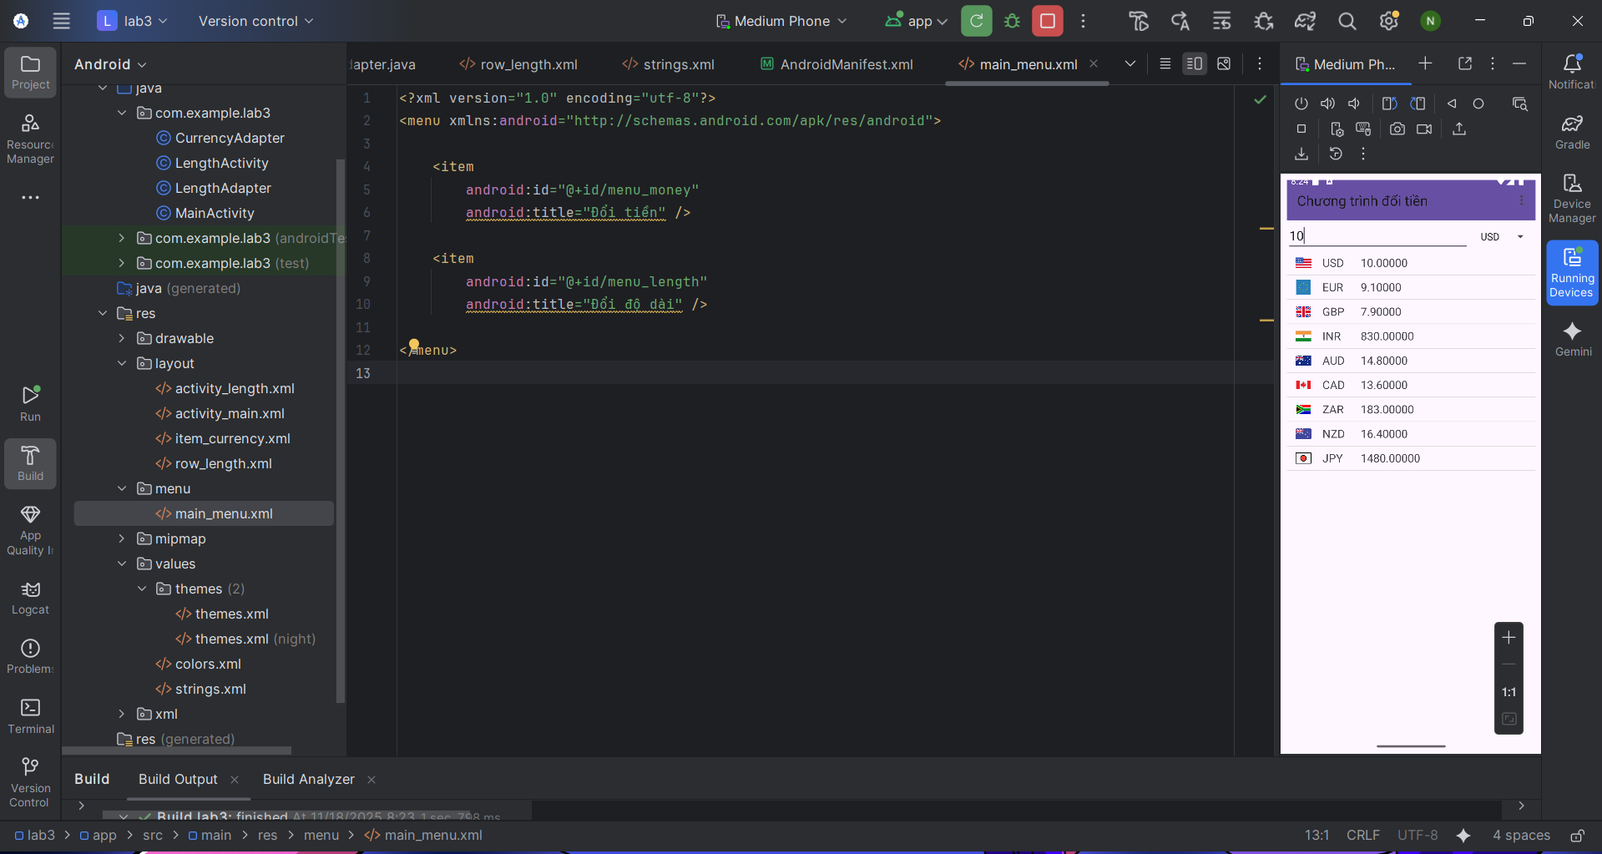Bài 2: Đổi đơn vị chiều dài
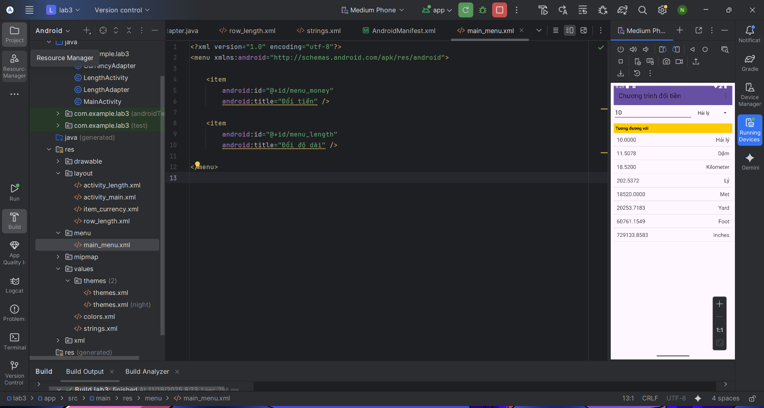

Bài 3: Custom Button
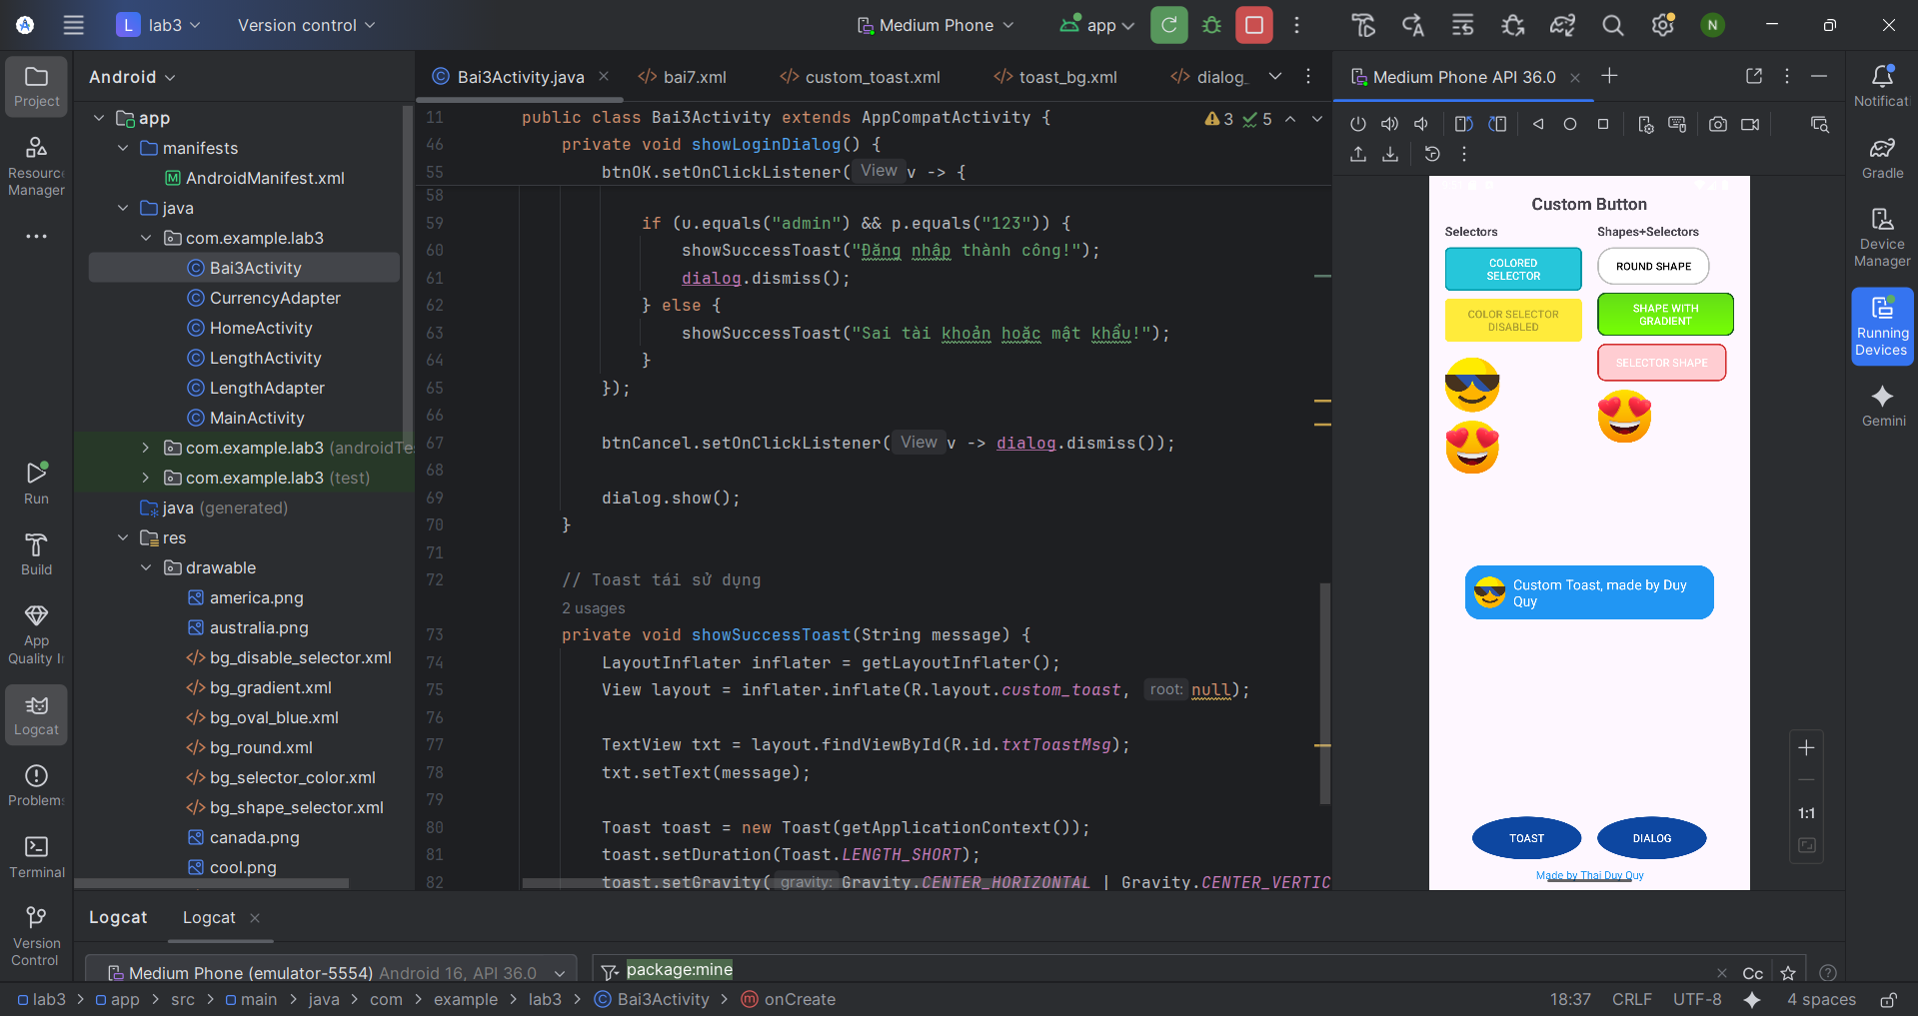
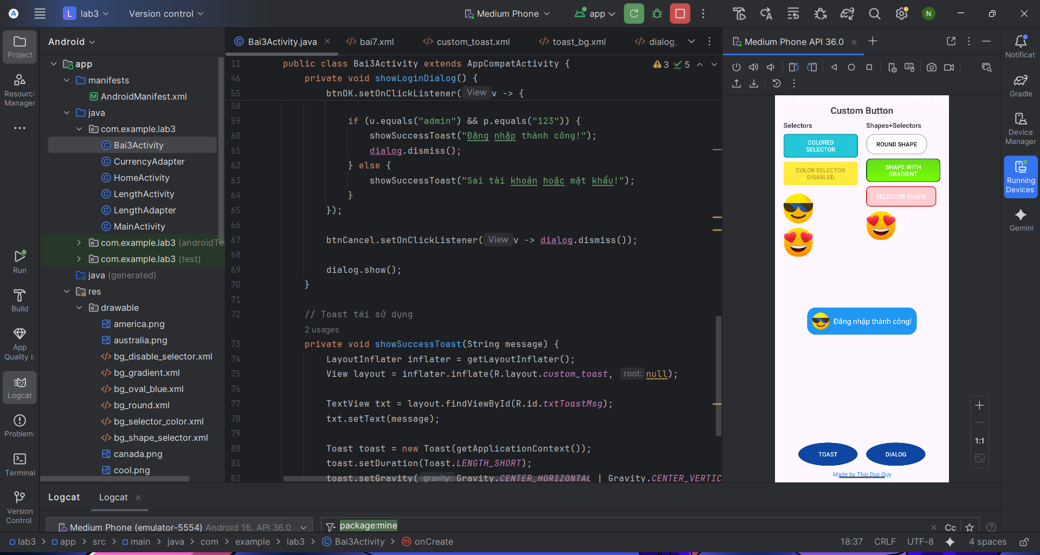
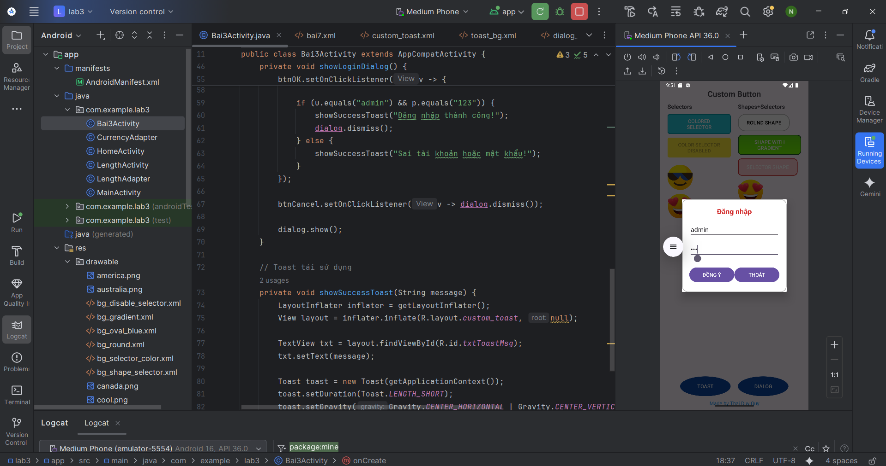

Bài 4: Chương trình cho phép chọn màu
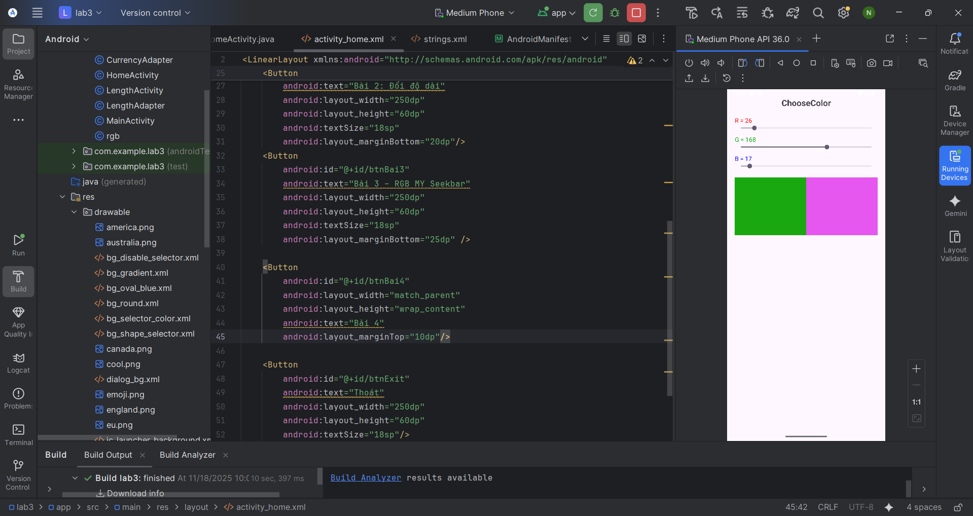

Bài 5: Chương trình hiển thị và quản lý các món ăn
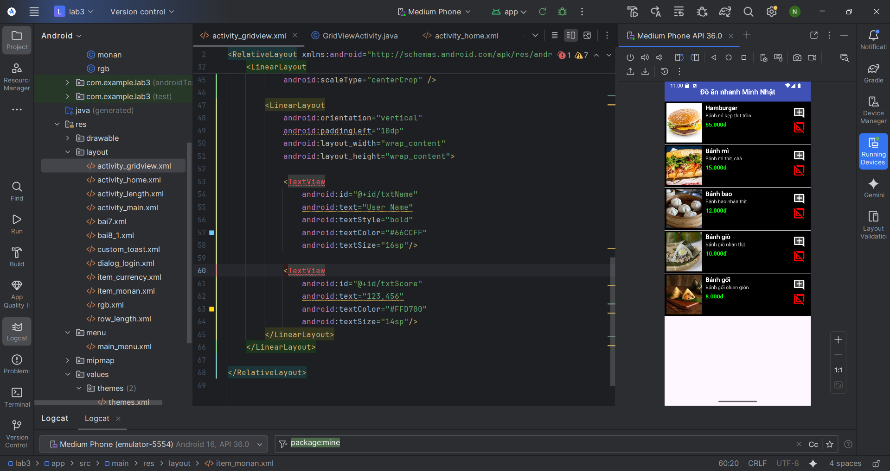

Bài 6: Sử dụng Custom GridView để thiết kế chương trình
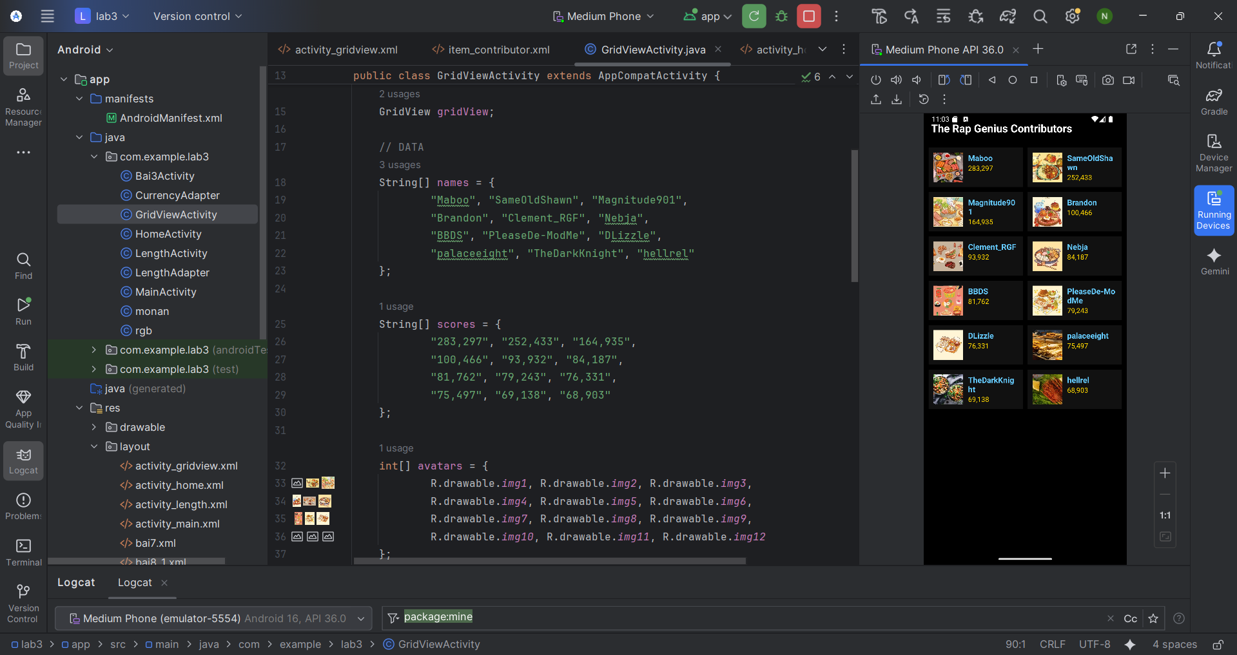

D.Lab4: Đề tài truyện ngắn đủ thể loại
AndroidManifest.xml
<?xml version="1.0" encoding="utf-8"?>
<manifest xmlns:android="http://schemas.android.com/apk/res/android"
xmlns:tools="http://schemas.android.com/tools">
<application
android:allowBackup="true"
android:dataExtractionRules="@xml/data_extraction_rules"
android:fullBackupContent="@xml/backup_rules"
android:icon="@mipmap/ic_launcher"
android:label="@string/app_name"
android:roundIcon="@mipmap/ic_launcher_round"
android:supportsRtl="true"
android:theme="@style/Theme.Lab4">
<activity
android:name=".MainActivity"
android:exported="true">
<intent-filter>
<action android:name="android.intent.action.MAIN" />
<category android:name="android.intent.category.LAUNCHER" />
</intent-filter>
</activity>
</application>
</manifest>
ĐẦU TIÊN TẠO CÁC FILE JAVA
Tạo đối tượng StoryEntity Tạo file Java StoryEntity.java để lưu trữ thông tin truyện
package com.example.lab4;
import java.io.Serializable;
public class StoryEntity implements Serializable {
private final String topicName;
private final String name;
private final String content;
public StoryEntity(String topicName, String name, String content) {
this.topicName = topicName;
this.name = name;
this.content = content;
}
public String getName() { return name; }
public String getContent() { return content; }
}
MainActivity (Bộ điều hướng)
Quản lý việc chuyển đổi giữa các màn hình: Splash -> Danh sách Thể loại -> Danh sách Truyện -> Đọc truyện
package com.example.lab4;
import android.os.Bundle;
import androidx.appcompat.app.AppCompatActivity;
import androidx.fragment.app.Fragment;
import java.util.ArrayList;
public class MainActivity extends AppCompatActivity {
@Override
protected void onCreate(Bundle savedInstanceState) {
super.onCreate(savedInstanceState);
setContentView(R.layout.activity_main);
showFrg(new M000SplashFrg()); // Màn hình chờ
}
private void showFrg(Fragment frg) {
getSupportFragmentManager().beginTransaction()
.replace(R.id.ln_main, frg, null) // ln_main là ID trong activity_main.xml
.addToBackStack(null) // Cho phép ấn Back để quay lại
.commit();
}
// Chuyển sang màn hình danh sách thể loại
public void gotoM001Screen() {
getSupportFragmentManager().beginTransaction()
.replace(R.id.ln_main, new M001TopicFrg(), null).commit();
}
// Chuyển sang màn hình danh sách truyện của 1 thể loại
public void gotoM002Screen(String topicName) {
M002StoryFrg frg = new M002StoryFrg();
frg.setTopicName(topicName); // Truyền tên thể loại vào
showFrg(frg);
}
// Chuyển sang màn hình đọc chi tiết
public void gotoM003Screen(ArrayList<StoryEntity> listStory, StoryEntity currentStory) {
M003DetailStoryFrg frg = new M003DetailStoryFrg();
frg.setData(listStory, currentStory);
showFrg(frg);
}
// Hàm quay lại
public void backToM001Screen() {
gotoM001Screen();
}
}
M001TopicFrg (Hiển thị các Thể loại)
package com.example.lab4;
import android.content.Context;
import android.graphics.BitmapFactory;
import android.os.Bundle;
import android.view.LayoutInflater;
import android.view.View;
import android.view.ViewGroup;
import android.widget.ImageView;
import android.widget.LinearLayout;
import android.widget.TextView;
import androidx.annotation.NonNull;
import androidx.fragment.app.Fragment;
public class M001TopicFrg extends Fragment {
private Context mContext;
@Override
public void onAttach(@NonNull Context context) {
super.onAttach(context);
mContext = context;
}
@Override
public View onCreateView(LayoutInflater inflater, ViewGroup container, Bundle savedInstanceState) {
View view = inflater.inflate(R.layout.m001_frg_topic, container, false);
initViews(view);
return view;
}
private void initViews(View v) {
LinearLayout lnMain = v.findViewById(R.id.ln_topic); // ID trong layout m001
lnMain.removeAllViews();
try {
// Lấy danh sách file trong thư mục photo
String[] listItem = mContext.getAssets().list("photo");
for (String fileName : listItem) {
// Tạo view từ layout item_topic
View vTopic = LayoutInflater.from(mContext).inflate(R.layout.item_topic, null);
ImageView ivTopic = vTopic.findViewById(R.id.iv_topic);
TextView tvTopic = vTopic.findViewById(R.id.tv_topic);
// Load ảnh từ assets
ivTopic.setImageBitmap(BitmapFactory.decodeStream(
mContext.getAssets().open("photo/" + fileName)));
// Cắt đuôi .png để lấy tên thể loại (VD: trinhtham.png -> trinhtham)
String name = fileName.substring(0, fileName.indexOf("."));
tvTopic.setText(name);
// Set sự kiện click
vTopic.setTag(name);
vTopic.setOnClickListener(view -> {
((MainActivity) getActivity()).gotoM002Screen((String) view.getTag());
});
// Add vào layout chính
lnMain.addView(vTopic);
}
} catch (Exception e) {
e.printStackTrace();
}
}
}
M002StoryFrg (Danh sách Truyện)
package com.example.lab4;
import android.content.Context;
import android.os.Bundle;
import android.view.LayoutInflater;
import android.view.View;
import android.view.ViewGroup;
import android.widget.TextView;
import androidx.annotation.NonNull;
import androidx.fragment.app.Fragment;
import androidx.recyclerview.widget.LinearLayoutManager;
import androidx.recyclerview.widget.RecyclerView;
import java.io.BufferedReader;
import java.io.InputStreamReader;
import java.util.ArrayList;
public class M002StoryFrg extends Fragment {
private Context mContext;
private String topicName; // Tên thể loại (VD: trinhtham)
@Override
public void onAttach(@NonNull Context context) {
super.onAttach(context);
mContext = context;
}
public void setTopicName(String topicName) {
this.topicName = topicName;
}
@Override
public View onCreateView(LayoutInflater inflater, ViewGroup container, Bundle savedInstanceState) {
View view = inflater.inflate(R.layout.m002_frg_story, container, false);
initViews(view);
return view;
}
private void initViews(View v) {
// Nút Back
v.findViewById(R.id.iv_back).setOnClickListener(v1 -> ((MainActivity)getActivity()).backToM001Screen());
// Set tên tiêu đề
((TextView) v.findViewById(R.id.tv_name)).setText("Truyện: " + topicName);
// Cài đặt RecyclerView
RecyclerView rv = v.findViewById(R.id.rv_story);
rv.setLayoutManager(new LinearLayoutManager(mContext));
// Đọc dữ liệu và đổ vào Adapter
ArrayList<StoryEntity> listStory = readStory();
StoryAdapter adapter = new StoryAdapter(listStory, mContext);
rv.setAdapter(adapter);
}
// LOGIC ĐỌC FILE QUAN TRỌNG
private ArrayList<StoryEntity> readStory() {
ArrayList<StoryEntity> list = new ArrayList<>();
BufferedReader reader = null;
try {
// Mở file txt tương ứng trong assets/story
reader = new BufferedReader(
new InputStreamReader(mContext.getAssets().open("story/" + topicName + ".txt"), "UTF-8"));
String line;
while ((line = reader.readLine()) != null) {
String title = line; // Dòng đầu tiên là tiêu đề
String content = "";
// Đọc tiếp các dòng nội dung cho đến khi gặp ký tự ngắt
while ((line = reader.readLine()) != null && !line.contains("','0');")) {
content += line + "\n";
}
// Tạo đối tượng truyện và thêm vào list
list.add(new StoryEntity(topicName, title, content));
}
} catch (Exception e) {
e.printStackTrace();
}
return list;
}
}
StoryAdapter (Cho RecyclerView ở màn M002)
package com.example.lab4;
import android.content.Context;
import android.view.LayoutInflater;
import android.view.View;
import android.view.ViewGroup;
import android.widget.TextView;
import androidx.annotation.NonNull;
import androidx.recyclerview.widget.RecyclerView;
import java.util.ArrayList;
public class StoryAdapter extends RecyclerView.Adapter<StoryAdapter.StoryHolder> {
private final ArrayList<StoryEntity> listStory;
private final Context mContext;
public StoryAdapter(ArrayList<StoryEntity> listStory, Context mContext) {
this.listStory = listStory;
this.mContext = mContext;
}
@NonNull
@Override
public StoryHolder onCreateViewHolder(@NonNull ViewGroup parent, int viewType) {
View view = LayoutInflater.from(mContext).inflate(R.layout.item_story, parent, false);
return new StoryHolder(view);
}
@Override
public void onBindViewHolder(@NonNull StoryHolder holder, int position) {
StoryEntity item = listStory.get(position);
holder.tvName.setText(item.getName());
// Bắt sự kiện click vào 1 truyện -> Chuyển sang màn đọc (M003)
holder.itemView.setOnClickListener(v -> {
((MainActivity) mContext).gotoM003Screen(listStory, item);
});
}
@Override
public int getItemCount() {
return listStory.size();
}
public static class StoryHolder extends RecyclerView.ViewHolder {
TextView tvName;
public StoryHolder(@NonNull View itemView) {
super(itemView);
tvName = itemView.findViewById(R.id.tv_story);
}
}
}
M003DetailStoryFrg (Màn hình Đọc truyện)
package com.example.lab4;
import android.content.Context;
import android.os.Bundle;
import android.view.LayoutInflater;
import android.view.View;
import android.view.ViewGroup;
import androidx.annotation.NonNull;
import androidx.fragment.app.Fragment;
import androidx.viewpager.widget.ViewPager;
import java.util.ArrayList;
public class M003DetailStoryFrg extends Fragment {
private ArrayList<StoryEntity> listStory;
private StoryEntity currentStory;
private Context mContext;
public void setData(ArrayList<StoryEntity> listStory, StoryEntity currentStory) {
this.listStory = listStory;
this.currentStory = currentStory;
}
@Override
public void onAttach(@NonNull Context context) {
super.onAttach(context);
mContext = context;
}
@Override
public View onCreateView(LayoutInflater inflater, ViewGroup container, Bundle savedInstanceState) {
View view = inflater.inflate(R.layout.m003_frg_detail_story, container, false);
initViews(view);
return view;
}
private void initViews(View v) {
v.findViewById(R.id.iv_back).setOnClickListener(view ->
((MainActivity)getActivity()).onBackPressed());
ViewPager vp = v.findViewById(R.id.vp_story);
// Gán Adapter cho ViewPager
DetailStoryAdapter adapter = new DetailStoryAdapter(listStory, mContext);
vp.setAdapter(adapter);
// Hiển thị đúng truyện người dùng vừa chọn
int index = listStory.indexOf(currentStory);
vp.setCurrentItem(index);
}
}
DetailStoryAdapter (Cho ViewPager màn M003)
package com.example.lab4;
import android.content.Context;
import android.view.LayoutInflater;
import android.view.View;
import android.view.ViewGroup;
import android.widget.TextView;
import androidx.annotation.NonNull;
import androidx.viewpager.widget.PagerAdapter;
import java.util.List;
public class DetailStoryAdapter extends PagerAdapter {
private final List<StoryEntity> listStory;
private final Context mContext;
public DetailStoryAdapter(List<StoryEntity> listStory, Context mContext) {
this.listStory = listStory;
this.mContext = mContext;
}
@NonNull
@Override
public Object instantiateItem(@NonNull ViewGroup container, int position) {
// Inflate layout chi tiết
View view = LayoutInflater.from(mContext).inflate(R.layout.item_detail_story, container, false);
StoryEntity item = listStory.get(position);
TextView tvName = view.findViewById(R.id.tv_name); // Tiêu đề
TextView tvContent = view.findViewById(R.id.tv_content); // Nội dung
tvName.setText(item.getName());
tvContent.setText(item.getContent());
container.addView(view);
return view;
}
@Override
public int getCount() {
return listStory.size();
}
@Override
public boolean isViewFromObject(@NonNull View view, @NonNull Object object) {
return view.equals(object);
}
@Override
public void destroyItem(@NonNull ViewGroup container, int position, @NonNull Object object) {
container.removeView((View) object);
}
}

Layout
Actionbar_home.xml
<?xml version="1.0" encoding="utf-8"?>
<LinearLayout xmlns:android="http://schemas.android.com/apk/res/android"
android:layout_width="match_parent"
android:layout_height="56dp"
android:background="@color/greenLight"
android:gravity="center_vertical"
android:orientation="horizontal"
android:paddingStart="10dp"
android:paddingEnd="10dp">
<ImageView
android:id="@+id/iv_back"
android:layout_width="40dp"
android:layout_height="40dp"
android:padding="8dp"
android:src="@drawable/ic_back"
android:visibility="gone"
android:contentDescription="Back" />
<TextView
android:id="@+id/tv_name"
android:layout_width="wrap_content"
android:layout_height="wrap_content"
android:layout_marginStart="10dp"
android:text="Truyện Ngắn"
android:textColor="@color/white"
android:textSize="20sp"
android:textStyle="bold" />
</LinearLayout>
Activity_main.xml
<?xml version="1.0" encoding="utf-8"?>
<LinearLayout xmlns:android="http://schemas.android.com/apk/res/android"
xmlns:tools="http://schemas.android.com/tools"
android:id="@+id/ln_main"
android:layout_width="match_parent"
android:layout_height="match_parent"
android:orientation="vertical"
tools:context=".MainActivity">
</LinearLayout>
Item_detail_story.xml
<?xml version="1.0" encoding="utf-8"?>
<LinearLayout xmlns:android="http://schemas.android.com/apk/res/android"
android:layout_width="match_parent"
android:layout_height="match_parent"
android:orientation="vertical"
android:padding="16dp">
<TextView
android:id="@+id/tv_name"
android:layout_width="match_parent"
android:layout_height="wrap_content"
android:gravity="center"
android:text="Tiêu đề truyện"
android:textColor="@color/greenMid"
android:textSize="24sp"
android:textStyle="bold"
android:layout_marginBottom="16dp"/>
<ScrollView
android:layout_width="match_parent"
android:layout_height="match_parent">
<TextView
android:id="@+id/tv_content"
android:layout_width="match_parent"
android:layout_height="wrap_content"
android:text="Nội dung..."
android:lineSpacingExtra="6dp"
android:textSize="18sp" />
</ScrollView>
</LinearLayout>
Item_story.xml
<?xml version="1.0" encoding="utf-8"?>
<LinearLayout xmlns:android="http://schemas.android.com/apk/res/android"
android:layout_width="match_parent"
android:layout_height="wrap_content"
android:orientation="vertical">
<LinearLayout
android:layout_width="match_parent"
android:layout_height="wrap_content"
android:padding="15dp"
android:gravity="center_vertical"
android:background="?attr/selectableItemBackground"
android:orientation="horizontal">
<ImageView
android:layout_width="40dp"
android:layout_height="40dp"
android:src="@drawable/ic_face"
app:tint="@color/greenMid"
xmlns:app="http://schemas.android.com/apk/res-auto"/>
<TextView
android:id="@+id/tv_story"
android:layout_width="match_parent"
android:layout_height="wrap_content"
android:layout_marginStart="10dp"
android:text="Tên truyện"
android:textSize="18sp"
android:textColor="@color/black"/>
</LinearLayout>
<View
android:layout_width="match_parent"
android:layout_height="1dp"
android:background="#E0E0E0"/>
</LinearLayout>
Item_topic.xml
<?xml version="1.0" encoding="utf-8"?>
<LinearLayout xmlns:android="http://schemas.android.com/apk/res/android"
android:layout_width="match_parent"
android:layout_height="wrap_content"
android:background="@color/white"
android:layout_marginBottom="2dp"
android:padding="10dp"
android:gravity="center_vertical"
android:orientation="horizontal">
<ImageView
android:id="@+id/iv_topic"
android:layout_width="80dp"
android:layout_height="80dp"
android:scaleType="centerCrop"
android:src="@color/teal_200" />
<TextView
android:id="@+id/tv_topic"
android:layout_width="match_parent"
android:layout_height="wrap_content"
android:layout_marginStart="15dp"
android:text="Tên Thể Loại"
android:textColor="@color/greenMid"
android:textSize="20sp"
android:textStyle="bold" />
</LinearLayout>
M000_frg_splash.xml
<?xml version="1.0" encoding="utf-8"?>
<FrameLayout xmlns:android="http://schemas.android.com/apk/res/android"
android:layout_width="match_parent"
android:layout_height="match_parent"
android:background="@color/greenMid">
<ImageView
android:layout_width="200dp"
android:layout_height="200dp"
android:layout_gravity="center"
android:src="@drawable/ic_splash"
android:contentDescription="Logo" />
</FrameLayout>
M001_frg_topic.xml
<?xml version="1.0" encoding="utf-8"?>
<LinearLayout xmlns:android="http://schemas.android.com/apk/res/android"
android:layout_width="match_parent"
android:layout_height="match_parent"
android:background="@color/greenSuperLight"
android:orientation="vertical">
<include layout="@layout/actionbar_home" />
<ScrollView
android:layout_width="match_parent"
android:layout_height="match_parent">
<LinearLayout
android:id="@+id/ln_topic"
android:layout_width="match_parent"
android:layout_height="wrap_content"
android:orientation="vertical"
android:padding="10dp" />
</ScrollView>
</LinearLayout>
M002_frg_story.xml
<?xml version="1.0" encoding="utf-8"?>
<LinearLayout xmlns:android="http://schemas.android.com/apk/res/android"
android:layout_width="match_parent"
android:layout_height="match_parent"
android:background="@color/white"
android:orientation="vertical">
<include layout="@layout/actionbar_home" />
<androidx.recyclerview.widget.RecyclerView
android:id="@+id/rv_story"
android:layout_width="match_parent"
android:layout_height="match_parent" />
</LinearLayout>
M003_frg_detail_story.xml
<?xml version="1.0" encoding="utf-8"?>
<LinearLayout xmlns:android="http://schemas.android.com/apk/res/android"
android:layout_width="match_parent"
android:layout_height="match_parent"
android:background="@color/white"
android:orientation="vertical">
<include layout="@layout/actionbar_home" />
<androidx.viewpager.widget.ViewPager
android:id="@+id/vp_story"
android:layout_width="match_parent"
android:layout_height="match_parent" />
</LinearLayout>
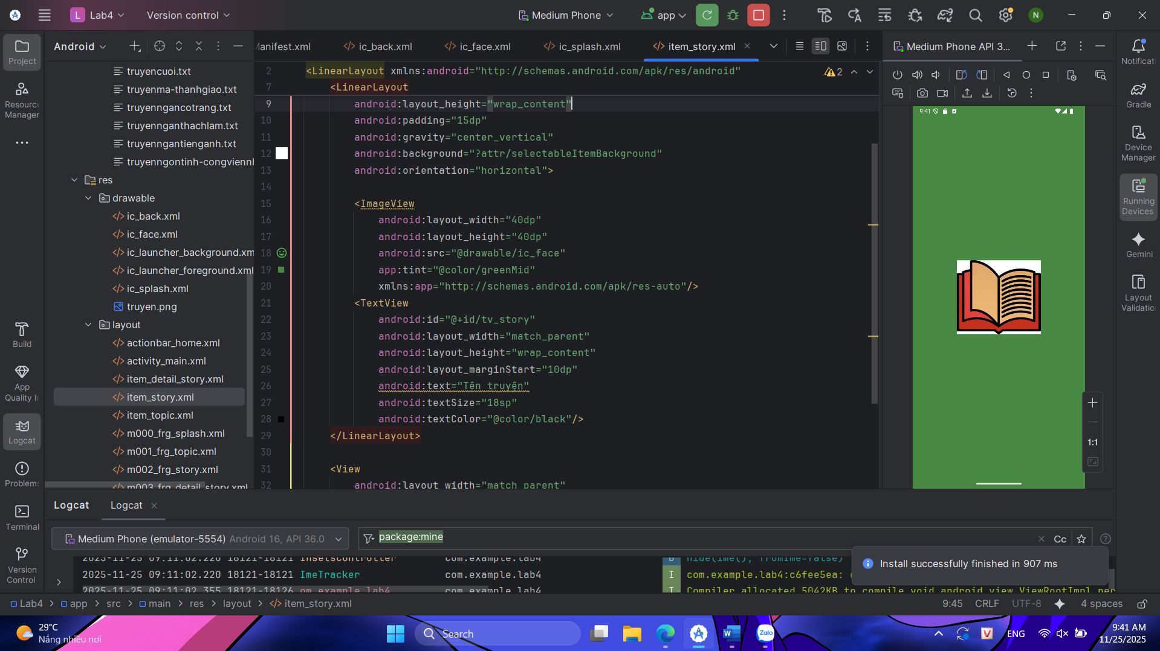
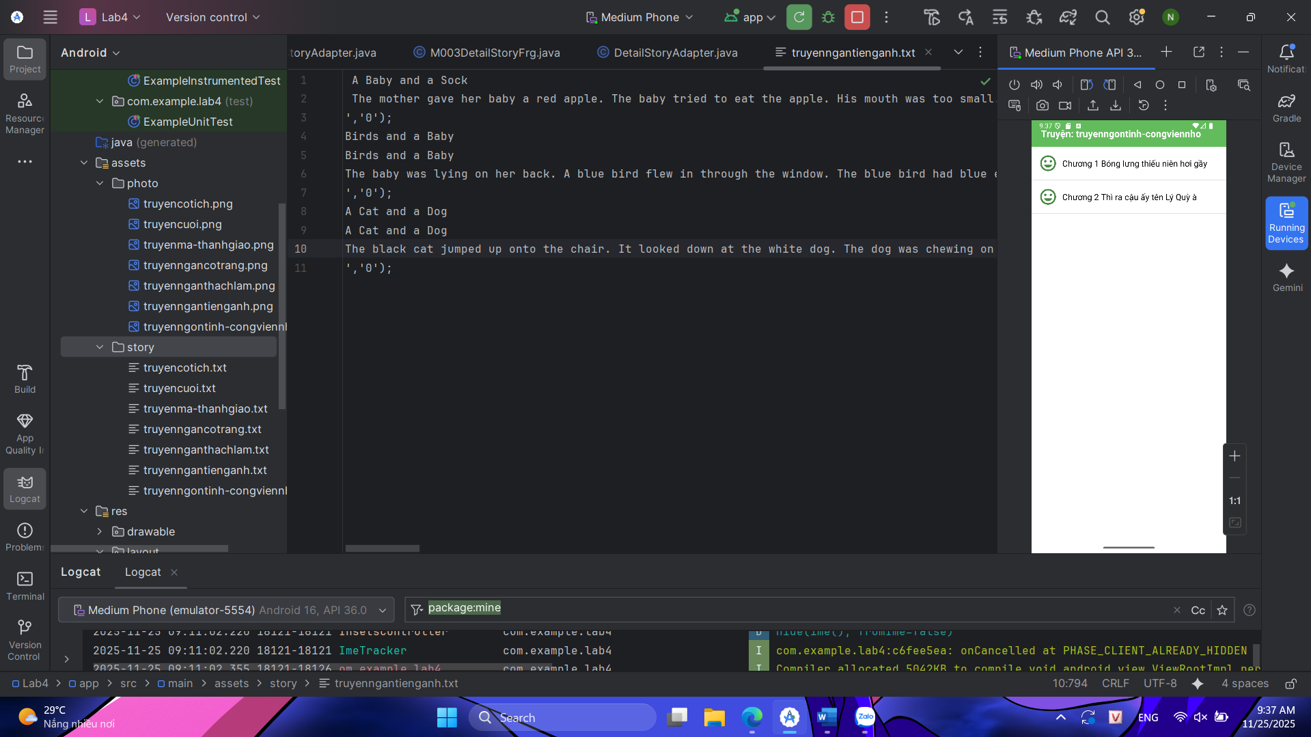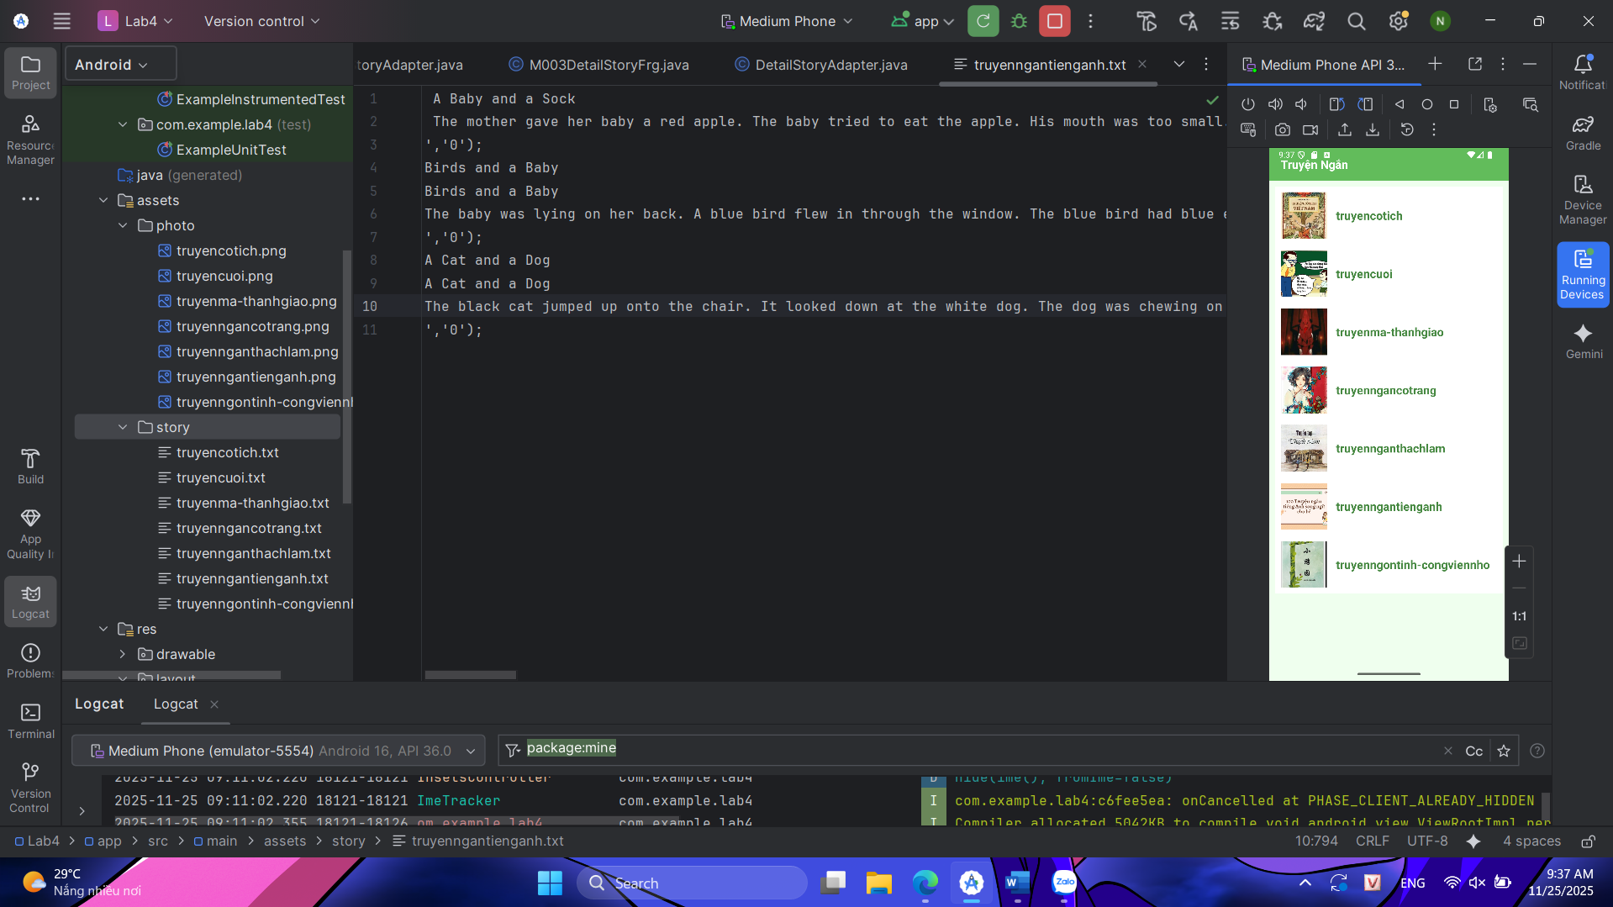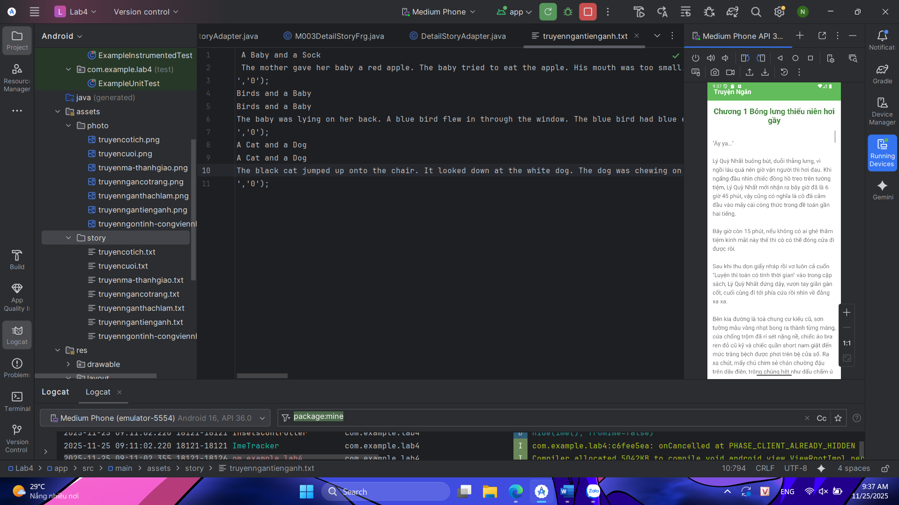

E.Lab5: Trang đăng nhập và đăng ký
Chuẩn bị sẵn các file trong drawable
Bg_radius.xml
<?xml version="1.0" encoding="utf-8"?>
<layer-list xmlns:android="http://schemas.android.com/apk/res/android">
<item android:drawable="@drawable/bg_rect" />
<item android:bottom="3dp">
<shape>
<corners android:radius="20dp"/>
<solid android:color="#ffffff" />
</shape>
</item>
</layer-list>
Bg_login.xml
<?xml version="1.0" encoding="utf-8"?><?xml version="1.0" encoding="utf-8"?>
<layer-list xmlns:android="http://schemas.android.com/apk/res/android">
<item android:drawable="@drawable/bg_rect" />
<item android:bottom="3dp">
<shape>
<corners android:radius="20dp"/>
<gradient
android:angle="180"
android:endColor="@color/orange"
android:startColor="@color/orangeMid"/>
</shape>
</item>
</layer-list>
Bg_top.xml
<?xml version="1.0" encoding="utf-8"?>
<shape xmlns:android="http://schemas.android.com/apk/res/android">
<corners android:bottomLeftRadius="100dp" />
<gradient
android:angle="145"
android:endColor="@color/orange"
android:startColor="@color/orangeMid"/>
</shape>
Bg_rect.xml
<?xml version="1.0" encoding="utf-8"?>
<shape xmlns:android="http://schemas.android.com/apk/res/android"
android:shape="rectangle">
<solid android:color="#CCCCCC"/>
<corners android:radius="20dp"/>
</shape>
Các icon
Ic_back.xml
<vector xmlns:android="http://schemas.android.com/apk/res/android" android:autoMirrored="true" android:height="24dp" android:tint="#000000" android:viewportHeight="960" android:viewportWidth="960" android:width="24dp">
<path android:fillColor="@android:color/white" android:pathData="M313,520L537,744L480,800L160,480L480,160L537,216L313,440L800,440L800,520L313,520Z"/>
</vector>
Ic_email.xml
<vector xmlns:android="http://schemas.android.com/apk/res/android" android:height="24dp" android:tint="#000000" android:viewportHeight="24" android:viewportWidth="24" android:width="24dp">
<path android:fillColor="@android:color/white" android:pathData="M3,6l8,5l8,-5v3h2V4c0,-1.1 -0.9,-2 -2,-2H3C1.9,2 1.01,2.9 1.01,4L1,16c0,1.1 0.9,2 2,2h10v-2H3V6zM19,4l-8,5L3,4H19z"/>
<path android:fillColor="@android:color/white" android:pathData="M21,14v4c0,1.1 -0.9,2 -2,2s-2,-0.9 -2,-2v-4.5c0,-0.28 0.22,-0.5 0.5,-0.5s0.5,0.22 0.5,0.5V18h2v-4.5c0,-1.38 -1.12,-2.5 -2.5,-2.5S15,12.12 15,13.5V18c0,2.21 1.79,4 4,4s4,-1.79 4,-4v-4H21z"/>
</vector>
Ic_key.xml
<vector xmlns:android="http://schemas.android.com/apk/res/android" android:height="24dp" android:tint="#000000" android:viewportHeight="960" android:viewportWidth="960" android:width="24dp">
<path android:fillColor="@android:color/white" android:pathData="M864,920L741,798Q723,809 702.5,814.5Q682,820 660,820Q594,820 547,773Q500,726 500,660Q500,594 547,547Q594,500 660,500Q726,500 773,547Q820,594 820,660Q820,683 814,703.5Q808,724 797,742L920,864L864,920ZM220,820Q154,820 107,773Q60,726 60,660Q60,594 107,547Q154,500 220,500Q286,500 333,547Q380,594 380,660Q380,726 333,773Q286,820 220,820ZM220,740Q253,740 276.5,716.5Q300,693 300,660Q300,627 276.5,603.5Q253,580 220,580Q187,580 163.5,603.5Q140,627 140,660Q140,693 163.5,716.5Q187,740 220,740ZM660,740Q693,740 716.5,716.5Q740,693 740,660Q740,627 716.5,603.5Q693,580 660,580Q627,580 603.5,603.5Q580,627 580,660Q580,693 603.5,716.5Q627,740 660,740ZM220,380Q154,380 107,333Q60,286 60,220Q60,154 107,107Q154,60 220,60Q286,60 333,107Q380,154 380,220Q380,286 333,333Q286,380 220,380ZM660,380Q594,380 547,333Q500,286 500,220Q500,154 547,107Q594,60 660,60Q726,60 773,107Q820,154 820,220Q820,286 773,333Q726,380 660,380ZM220,300Q253,300 276.5,276.5Q300,253 300,220Q300,187 276.5,163.5Q253,140 220,140Q187,140 163.5,163.5Q140,187 140,220Q140,253 163.5,276.5Q187,300 220,300ZM660,300Q693,300 716.5,276.5Q740,253 740,220Q740,187 716.5,163.5Q693,140 660,140Q627,140 603.5,163.5Q580,187 580,220Q580,253 603.5,276.5Q627,300 660,300ZM220,660Q220,660 220,660Q220,660 220,660Q220,660 220,660Q220,660 220,660Q220,660 220,660Q220,660 220,660Q220,660 220,660Q220,660 220,660ZM220,220Q220,220 220,220Q220,220 220,220Q220,220 220,220Q220,220 220,220Q220,220 220,220Q220,220 220,220Q220,220 220,220Q220,220 220,220ZM660,220Q660,220 660,220Q660,220 660,220Q660,220 660,220Q660,220 660,220Q660,220 660,220Q660,220 660,220Q660,220 660,220Q660,220 660,220Z"/>
</vector>
Bước 1: Chuẩn bị tài nguyên
Cấu hình màu sắc
Colors.xml
<?xml version="1.0" encoding="utf-8"?>
<resources>
<color name="purple_200">#FFBB86FC</color>
<color name="purple_500">#FF6200EE</color>
<color name="purple_700">#F4511E</color>
<color name="teal_200">#FF03DAC5</color>
<color name="teal_700">#FF018786</color>
<color name="black">#FF000000</color>
<color name="white">#FFFFFFFF</color>
<color name="orange">#FB8C00</color>
<color name="gray">#EAE5E3</color>
<color name="orangeMid">#F4511E</color>
</resources>
Khai báo đoạn text hiển thị
Strings.xml
<resources>
<string name="app_name">Login</string>
<string name="txt_login">Login</string>
<string name="hint_email">Email</string>
<string name="hint_password">Password</string>
<string name="txt_forgot_pass">Forgot password?</string>
<string name="txt_no_account">Don\'t have an account ?</string>
<string name="txt_register">Register</string>
</resources>
Bước 2: Thiết kế giao diện
Activity_main.xml
<?xml version="1.0" encoding="utf-8"?>
<LinearLayout xmlns:android="http://schemas.android.com/apk/res/android"
android:id="@+id/ln_main"
android:layout_width="match_parent"
android:layout_height="match_parent"
android:orientation="vertical">
</LinearLayout>
Tạo giao diện đăng nhập
M000_frg_login.xml
<?xml version="1.0" encoding="utf-8"?>
<LinearLayout xmlns:android="http://schemas.android.com/apk/res/android"
android:layout_width="match_parent"
android:layout_height="match_parent"
android:background="@color/gray"
android:orientation="vertical">

<FrameLayout
android:layout_width="match_parent"
android:layout_height="wrap_content">
<View
android:layout_width="match_parent"
android:layout_height="300dp"
android:background="@drawable/bg_top"/>
<TextView
android:layout_width="wrap_content"
android:layout_height="wrap_content"
android:layout_gravity="end"
android:layout_marginTop="220dp"
android:layout_marginEnd="30dp"
android:layout_marginRight="30dp"
android:text="@string/txt_login"
android:textColor="@color/white"
android:textSize="20sp" />
</FrameLayout>

<EditText
android:id="@+id/edt_email"
android:layout_width="match_parent"
android:layout_height="50dp"
android:layout_marginHorizontal="30dp"
android:layout_marginTop="50dp"
android:layout_marginBottom="3dp"
android:background="@drawable/bg_radius"
android:drawableLeft="@drawable/ic_email"
android:drawablePadding="10dp"
android:hint="@string/hint_email"
android:inputType="textEmailAddress"
android:padding="10dp"
android:textSize="18sp"
android:autofillHints="Email"/>

<EditText
android:id="@+id/edt_pass"
android:layout_width="match_parent"
android:layout_height="50dp"
android:layout_marginHorizontal="30dp"
android:layout_marginTop="20dp"
android:layout_marginBottom="3dp"
android:background="@drawable/bg_radius"
android:drawableLeft="@drawable/ic_key"
android:drawablePadding="10dp"
android:hint="@string/hint_password"
android:inputType="textPassword"
android:padding="10dp"
android:textSize="18sp"
android:autofillHints="Password"/>

<TextView
android:layout_width="wrap_content"
android:layout_height="wrap_content"
android:layout_gravity="end"
android:layout_marginTop="10dp"
android:layout_marginRight="30dp"
android:text="@string/txt_forgot_pass"
android:textColor="@color/black"
android:textSize="18sp" />

<TextView
android:id="@+id/tv_login"
android:layout_width="match_parent"
android:layout_height="50dp"
android:layout_gravity="end"
android:layout_marginHorizontal="30dp"
android:layout_marginTop="40dp"
android:background="@drawable/bg_login"
android:gravity="center"
android:padding="10dp"
android:text="@string/txt_login"
android:textColor="@color/white"
android:textSize="18sp" />

<TableRow
android:layout_width="match_parent"
android:layout_height="wrap_content"
android:layout_marginTop="30dp"
android:gravity="center">
<TextView
android:layout_width="wrap_content"
android:layout_height="wrap_content"
android:layout_gravity="end"
android:text="@string/txt_no_account"
android:textColor="@color/black"
android:textSize="14sp" />
<TextView
android:id="@+id/tv_register"
android:layout_marginLeft="5dp"
android:layout_width="wrap_content"
android:layout_height="wrap_content"
android:layout_gravity="end"
android:text="@string/txt_register"
android:textColor="@color/orange"
android:textSize="14sp"
android:textStyle="bold" />
</TableRow>
</LinearLayout>
Tạo giao diện đăng ký
m001_frg_register.xml
<?xml version="1.0" encoding="utf-8"?>
<LinearLayout xmlns:android="http://schemas.android.com/apk/res/android"
xmlns:app="http://schemas.android.com/apk/res-auto"
xmlns:tools="http://schemas.android.com/tools"
android:layout_width="match_parent"
android:layout_height="match_parent"
android:background="@color/gray"
android:orientation="vertical">

<FrameLayout
android:layout_width="match_parent"
android:layout_height="wrap_content">
<View
android:layout_width="match_parent"
android:layout_height="300dp"
android:background="@drawable/bg_top"/>
<ImageView
android:id="@+id/iv_back"
android:layout_width="56dp"
android:layout_height="56dp"
android:padding="10dp"
android:src="@drawable/ic_back"
app:tint="@color/white"
tools:ignore="ContentDescription"/>
<TextView
android:layout_width="wrap_content"
android:layout_height="wrap_content"
android:layout_gravity="end"
android:layout_marginTop="220dp"
android:layout_marginRight="30dp"
android:text="@string/txt_register"
android:textColor="@color/white"
android:textSize="20sp" />
</FrameLayout>

<EditText
android:id="@+id/edt_email"
android:layout_width="match_parent"
android:layout_height="50dp"
android:layout_marginHorizontal="30dp"
android:layout_marginTop="50dp"
android:layout_marginBottom="3dp"
android:autofillHints="Email"
android:background="@drawable/bg_radius"
android:drawableLeft="@drawable/ic_email"
android:drawablePadding="10dp"
android:hint="@string/hint_email"
android:inputType="textEmailAddress"
android:padding="10dp"
android:textSize="18sp" />

<EditText
android:id="@+id/edt_pass"
android:layout_width="match_parent"
android:layout_height="50dp"
android:layout_marginHorizontal="30dp"
android:layout_marginTop="10dp"
android:layout_marginBottom="3dp"
android:autofillHints="Password"
android:background="@drawable/bg_radius"
android:drawableLeft="@drawable/ic_key"
android:drawablePadding="10dp"
android:hint="@string/hint_password"
android:inputType="textPassword"
android:padding="10dp"
android:textSize="18sp" />

<EditText
android:id="@+id/edt_re_pass"
android:layout_width="match_parent"
android:layout_height="50dp"
android:layout_marginHorizontal="30dp"
android:layout_marginTop="10dp"
android:layout_marginBottom="3dp"
android:autofillHints="Password"
android:background="@drawable/bg_radius"
android:drawableLeft="@drawable/ic_key"
android:drawablePadding="10dp"
android:hint="@string/hint_password"
android:inputType="textPassword"
android:padding="10dp"
android:textSize="18sp" />

<TextView
android:id="@+id/tv_register"
android:layout_width="match_parent"
android:layout_height="50dp"
android:layout_gravity="end"
android:layout_marginHorizontal="30dp"
android:layout_marginTop="20dp"
android:background="@drawable/bg_login"
android:gravity="center"
android:padding="10dp"
android:text="@string/txt_register"
android:textColor="@color/white"
android:textSize="18sp" />
</LinearLayout>
Xử lý logic
MainActivity.java
package com.techja.account;

import android.os.Bundle;
import androidx.appcompat.app.AppCompatActivity;

public class MainActivity extends AppCompatActivity {
public static final String SAVE_PREF = "save_pref";

@Override
protected void onCreate(Bundle savedInstanceState) {
super.onCreate(savedInstanceState);
setContentView(R.layout.activity_main);
gotoLoginScreen();
}

public void gotoRegisterScreen() {
getSupportFragmentManager().beginTransaction()
.replace(R.id.ln_main, new M001RegisterFragment())
.commit();
}

public void gotoLoginScreen() {
getSupportFragmentManager().beginTransaction()
.replace(R.id.ln_main, new M000LoginFragment())
.commit();
}
}
Xử lý logic đăng nhập
M000LoginFragment.java
package com.techja.account;

import android.content.Context;
import android.content.SharedPreferences;
import android.os.Bundle;
import android.view.LayoutInflater;
import android.view.View;
import android.view.ViewGroup;
import android.view.animation.AnimationUtils;
import android.widget.EditText;
import android.widget.Toast;
import androidx.fragment.app.Fragment;

public class M000LoginFragment extends Fragment implements View.OnClickListener {
private EditText edtEmail, edtPass;
private Context mContext;

@Override
public View onCreateView(LayoutInflater inflater, ViewGroup container, Bundle savedInstanceState) {
View rootView = inflater.inflate(R.layout.m000_frg_login, container, false);
initView(rootView);
return rootView;
}

@Override
public void onAttach(Context context) {
super.onAttach(context);
mContext = context;
}

private void initView(View v) {
edtEmail = v.findViewById(R.id.edt_email);
edtPass = v.findViewById(R.id.edt_pass);
v.findViewById(R.id.tv_login).setOnClickListener(this);
v.findViewById(R.id.tv_register).setOnClickListener(this);
}

@Override
public void onClick(View v) {
v.startAnimation(AnimationUtils.loadAnimation(mContext, androidx.appcompat.R.anim.abc_fade_in));
if (v.getId() == R.id.tv_login) {
login(edtEmail.getText().toString(), edtPass.getText().toString());
} else if (v.getId() == R.id.tv_register) {
gotoRegisterScreen();
}
}

private void gotoRegisterScreen() {
((MainActivity) mContext).gotoRegisterScreen();
}

private void login(String mail, String pass) {
if (mail.isEmpty() || pass.isEmpty()) {
Toast.makeText(mContext, "Empty value", Toast.LENGTH_SHORT).show();
return;
}
SharedPreferences pref = mContext.getSharedPreferences(MainActivity.SAVE_PREF, Context.MODE_PRIVATE);
String savedPass = pref.getString(mail, null);
if (savedPass == null) {
Toast.makeText(mContext, "Email is not existed!", Toast.LENGTH_SHORT).show();
return;
}
if (!pass.equals(savedPass)) {
Toast.makeText(mContext, "Password is not correct!", Toast.LENGTH_SHORT).show();
return;
}
Toast.makeText(mContext, "Login account successfully!", Toast.LENGTH_SHORT).show();
}
}
Xử lý logic đăng ký
M001RegisterFragment.java
package com.techja.account;

import android.content.Context;
import android.content.SharedPreferences;
import android.os.Bundle;
import android.view.LayoutInflater;
import android.view.View;
import android.view.ViewGroup;
import android.view.animation.AnimationUtils;
import android.widget.EditText;
import android.widget.Toast;
import androidx.fragment.app.Fragment;

public class M001RegisterFragment extends Fragment implements View.OnClickListener {
private EditText edtEmail, edtPass, edtRepass;
private Context mContext;

@Override
public View onCreateView(LayoutInflater inflater, ViewGroup container, Bundle savedInstanceState) {
View rootView = inflater.inflate(R.layout.m001_frg_register, container, false);
initView(rootView);
return rootView;
}

@Override
public void onAttach(Context context) {
super.onAttach(context);
mContext = context;
}

private void initView(View v) {
edtEmail = v.findViewById(R.id.edt_email);
edtPass = v.findViewById(R.id.edt_pass);
edtRepass = v.findViewById(R.id.edt_re_pass);
v.findViewById(R.id.tv_register).setOnClickListener(this);
v.findViewById(R.id.iv_back).setOnClickListener(this);
}

@Override
public void onClick(View v) {
v.startAnimation(AnimationUtils.loadAnimation(mContext, androidx.appcompat.R.anim.abc_fade_in));
if (v.getId() == R.id.iv_back) {
gotoLoginScreen();
} else if (v.getId() == R.id.tv_register) {
register(edtEmail.getText().toString(), edtPass.getText().toString(), edtRepass.getText().toString());
}
}

private void gotoLoginScreen() {
((MainActivity) mContext).gotoLoginScreen();
}

private void register(String mail, String pass, String repass) {
if (mail.isEmpty() || pass.isEmpty() || repass.isEmpty()) {
Toast.makeText(mContext, "Empty value", Toast.LENGTH_SHORT).show();
return;
}
if (!pass.equals(repass)) {
Toast.makeText(mContext, "Password is not match", Toast.LENGTH_SHORT).show();
return;
}
SharedPreferences pref = mContext.getSharedPreferences(MainActivity.SAVE_PREF, Context.MODE_PRIVATE);
String savedPass = pref.getString(mail, null);
if (savedPass != null) {
Toast.makeText(mContext, "Email is existed!", Toast.LENGTH_SHORT).show();
return;
}
pref.edit().putString(mail, pass).apply();
Toast.makeText(mContext, "Register account successfully!", Toast.LENGTH_SHORT).show();
gotoLoginScreen();
}
}
Kết quả
